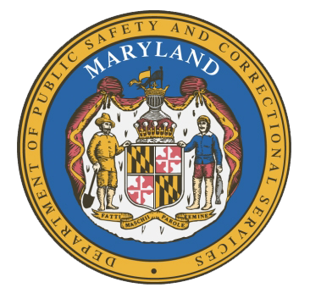
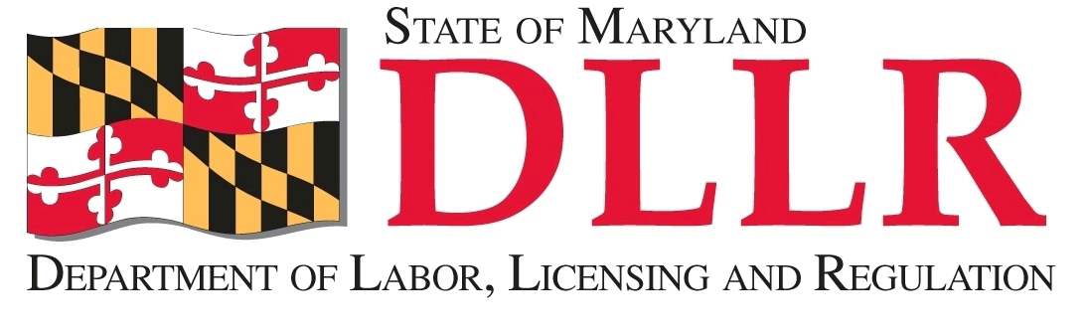
MARYLAND
Department of Public Safety and Correctional Services
In
Partnership
With

Correctional Education Council
Conference Call – Phone Number 252-397-0135, Code 201137563#

June 17, 2019
10:00 a.m. – 12:00 p.m.
Department of Labor, Licensing and Regulation
1100 North Eutaw Street, Room 108
Baltimore, MD 21201

Council Meeting Agenda

Welcome/Review of March 18, 2019 Minutes Secretary James Rzepkowski
Secretary Robert Green

DPSCS Updates Deputy Secretary Michael Zeigler

DLLR Updates Deputy Secretary David McGlone

Prison to Apprenticeship Christopher D. Maclarion

Correctional Education Updates Jack Cunning and Staff
- Staff Vacancies Jack Cunning
- Academic Updates Danielle Cox
- Occupational Updates Tamara Barron
- Transitional Updates Erica DuBose

Employer Engagement Committee Updates Jack Weber

Concluding Remarks Secretary James Rzepkowski
Secretary Robert Green

