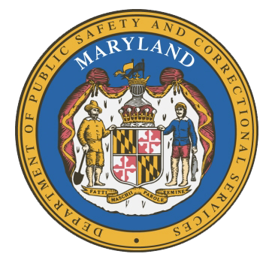
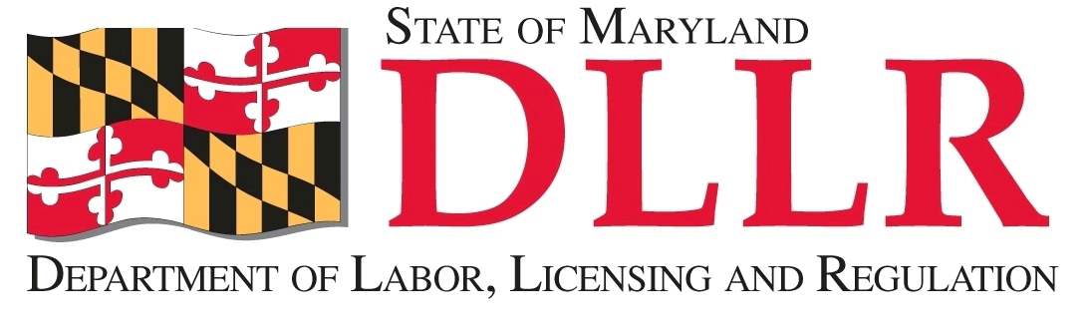
In
Partnership
With

MARYLAND
Department of Public Safety and Correctional Services

Correctional Education Council
June 12, 2017
10:00 am – 12:00 pm
Department of Labor, Licensing and Regulation
1100 North Eutaw Street, Room 108
Baltimore, MD 21201

Council Meeting Agenda

Welcome/Review of the March 2017 Minutes Secretary Kelly Schulz
Secretary Stephen Moyer

DPSCS Updates Secretary Stephen Moyer

DLLR Updates Secretary Kelly Schulz

American Prison Data Systems’ Tablet Arti Finn
Re-Entry Software Louise Wasilewski

Employer Engagement Subcommittee Report Jack Weber

Update on the Welding Program Tamara Barron

Correctional Education Updates Alice Wirth and Staff
- New Staff and Staff Vacancies Jack Cunning
- Correctional Education GED® Numbers Alice Wirth
- Occupational Updates Tamara Barron
- Transitional Updates Erica DuBose

Concluding Remarks Secretary Kelly Schulz
Secretary Stephen Moyer

