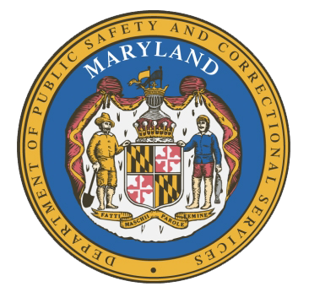
MARYLAND
Department of Public Safety and Correctional Services
In
Partnership
With



Correctional Education Council-Hybrid Meeting
Conference Call – Phone Number ‪(US) +1 ‪(US) +1 561-614-0676‬ PIN: ‪405 201 372‬#

December 12, 2022
10:00 a.m. – 12:00 p.m.
For those that wish to join us in person, please meet in:
LABOR-DWD-CR1-209-LG-Eutaw

Council Meeting Agenda

Welcome Secretary Tiffany Robinson
Review/Vote on June 13, 2022 and
September 12, 2022 Minutes

DPSCS Updates Secretary Robert Green

Labor Updates Secretary Tiffany Robinson

Vote on 2023 Meeting Dates Jack Cunning

Correctional Education Updates
- Staff Vacancies Dr. Jack Cunning
- Academic Patrick Hruz
- Special Education Katharine Lander
- Occupational Dr. Tamara Barron
- Transition Dr. Erica DuBose

Regional Principal Updates
- Western Region Peggy Stanford
- Central Region Christina Sparr
- Eastern Region and Library Updates Melissa Murphy

Community Partner Felicia McClean
Reentry Coordinator for Prince George’s County
Welcome Home Reentry Program
Catholic Charities of the
Archdiocese of Washington

Navigator Updates Marshel Pollock-Lawrence

Employer Engagement Committee Updates Jack Weber

Concluding Remarks Secretary Tiffany Robinson
Secretary Robert Green

CEC 2023 MEETING DATES

- March 13, 2023
- June 12, 2023
- September 11, 2023
- December 11, 2023

