FY 2021 State OSHA Annual Report (SOAR):
Maryland Occupational Safety and Health

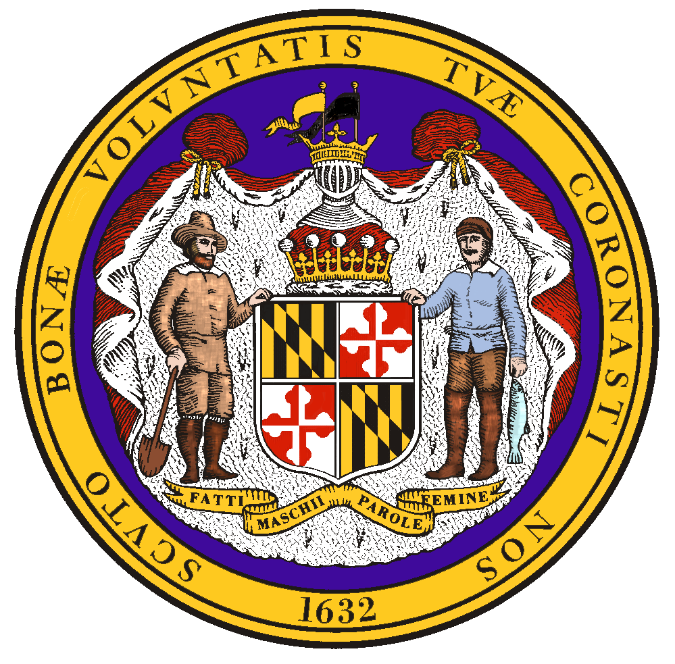

Evaluation Period: October 1, 2020- September 30, 2021
Prepared by: Maryland Occupational Safety and Health
Submitted: January 4, 2022

Larry Hogan, Governor
Tiffany Robinson, Secretary
Matthew Helminiak, Commissioner
Table of Contents:

- Executive Summary……………………………………………………………………... 1
- Summary of Annual Performance Plan Results………………………………………. 2
- Progress Toward Strategic Plan Accomplishments: Performance & Activity Results 2
- Mandated Activities……………………………………………………………………... 8
- Special Measures of Effectiveness/Special Accomplishments………………………… 14
- Adjustments or Other Issues……………………………………………………………. 17

- Executive Summary
During Fiscal Year 2021 (FY21), Maryland Occupational Safety and Health (MOSH) again dealt with the pandemic from the SARS-CoV-2 virus that began in early March 2020. The SARS-CoV-2 virus that causes the COVID-19 disease is a highly infectious virus transmitted primarily through respiratory droplets. As the pandemic spread across the nation, the state of Maryland took proactive measures to respond to COVID-19 following the Governor’s Executive Orders. These orders leveraged the local county health departments to enforce the Governor’s Executive Orders, while MOSH responded by enforcing applicable occupational safety and health standards to ensure employees were protected. MOSH received historic levels of inquiries, complaints, and general questions related to COVID-19. While responding to this pandemic, MOSH staff established new protocols and procedures, utilized new forms of technology, and applied strong teamwork to protect workers in Maryland. MOSH was able to maintain an effective enforcement program, despite the operational challenges posed by the pandemic, while meeting or exceeding most goals and mandated measures of the FY21 grant year. Specifically, in addition to the COVID-19 unprogrammed response activity, MOSH was able to conduct 787 comprehensive program planned inspections.
MOSH FY21 Overview:
- 1,106 safety inspections identifying 5,369 hazards, which resulted in 4,191 citations.
- 101 health inspections identifying 523 hazards, which resulted in 421 citations.

- Summary of Annual Performance Plan Results & III. Progress Toward Strategic Plan Accomplishments
Strategic Goal 1: Improve workplace safety and health through compliance assistance and enforcement of occupational safety and health regulations.
Performance Goal 1.1: Total Reduction in the Fatality Rate by 1% (5% by end of Federal Fiscal Year [FFY] 2022)
Performance Goal 1.2: Reduce the rate of occupational injuries and illnesses in Maryland’s private sector by 1% (5% by end of FFY 2022)
Performance Goal 1.3: Reduce the rate of occupational injuries and illnesses in Maryland’s State and local government sector by 2% (10% by the end of FFY 2022)
Unit Responsible (date source) | Performance Indicator | Result | Comments
Enforcement/  Compliance  Assistance  Consultation  OSHA Information System (OIS) Data for various metrics  (Bureau of Labor Statistics [BLS] survey of occupational injuries and illnesses) | Perform inspection and intervention activity in the following areas:  Industry FY2021 Projected  - Construction (NAICS 23)…….....1464  - Other high-hazard industries….....488  (NAICS 11, 5617, 562, 622-624, 71, 721)  - Public Sector……………………..195  - Manufacturing (NAICS 31-33)…..170  - Trade, Transportation, Utilities…..122  (NAICS 2213, 424, 44-45, 48-49)  Conduct the following number of Consultation visits:  Industry FY2021 Projected  - Construction (NAICS 23)………..158  - Other high-hazard industries……..24  (NAICS 11, 5617, 562, 622-624, 71, 721)  - Public Sector…..……..…………...61  - Manufacturing (NAICS 31-33)…..91  - Trade, Transportation, Utilities…..36  (NAICS 2213, 424, 44-45, 48-49) | Industry 2021 Actual  - Construction (NAICS 23)…….....857  - Other high-hazard industries….....100  (NAICS 11, 5617, 562, 622-624, 71, 721)  - Public Sector……………………..56  - Manufacturing (NAICS 31-33).…78  - Trade, Transportation, Utilities.....111  (NAICS 2213, 424, 44-45, 48-49)  Industry 2021 Actual  - Construction (NAICS 23)……..See CAPR  - Other high-hazard industries......See CAPR  (NAICS 11, 5617, 562, 622-624, 71, 721)  - Public Sector………………………62  - Manufacturing (NAICS 31-33)….See CAPR  - Trade, Transportation, Utilities….See CAPR  (NAICS 2213, 424, 44-45, 48-49)  See CAPR for consultation results on Goal 1.2 | NOTE: Maryland’s private sector Days Away, Restricted, and Transfer (DART) rate for reference year 2020 was 1.6 injuries and illnesses per 100 full-time equivalent workers; 2019’s rate was 1.5.  MOSH had one 23(g) public sector consultant. All parameters for consultation can be found in the FY21 Consultation Annual Program Report (CAPR).
Strategic Goal 2: Promote a safety and health culture through Cooperative Programs, Compliance Assistance, On-site Consultation Programs, Outreach, Training and Education, and Informative Services.
Performance Goal 2.1: Increase Recognition Programs from 23 to 24 (5 new Recognition programs by end of FFY 2022)
Unit Responsible (data source) | Performance Indicator | Result | Comments
Compliance Assistance  (report from consultation unit and Voluntary Protection Program [VPP] unit) | Increase Recognition Programs by 1 new company for FY21. | There were no new sites added for FY21. | By the end of FY21, MOSH recertified 2 Consultation Safety and Health Achievement Recognition Program (SHARP) sites and approved two mid-year employer self-evaluations for SHARP. MOSH maintained 20 VPP STAR sites. The evaluation of one new application was delayed by the pandemic.
Performance Goal 2.2: Increase Cooperative Partnerships from 94 to 97 (add 15 new cooperative partnerships by the end of FFY 2022)
Unit Responsible (data source) | Performance Indicator | Result | Comments
Compliance Assistance  (report from partnership and alliance unit) | Increase MOSH Cooperative Partnerships by 1 new partnership in FY21. | MOSH signed two new cooperative partnerships in FY21. | MOSH is currently on pace to exceed the goal laid out in the 5-year strategic plan.
Performance Goal 2.3: Increase Strategic Partnership for Excellence in Construction Safety (SPECS) partnerships from 6 to 9 (add 15 new partnerships by the end of FFY 2022)
Unit Responsible (data source) | Performance Indicator | Result |  | Comments
Compliance Assistance (report from training and education unit) | Increase SPECS Partnerships by 3 new partnerships in FY21. | There were no new SPECS sites added for FY21. |  | There were no new SPECS sites added for FY21.
Performance Goal 2.4: Maintain attendance in MOSH outreach and training programs annually at 6,000 participants
Unit Responsible (data source) | Performance Indicator | Result |  | Comments
Compliance Assistance (report from training and education unit) | Maintain the total number of trainees/participants anticipated to be affected by outreach activities in the areas covered by MOSH LEP’s, current SST, and Federal NEP’s including formal training, workshops, seminars, speeches, conferences, and informal worksite training at 6,000. | In FY21, 8 different employers, institutions, and government agencies requested a MOSH compliance officer to speak at their job site. MOSH speakers spent over 10 hours presenting various safety and health topics to employees. MOSH continues to consider teen safety to be an important topic to cover with high school students who are preparing to enter the workforce. Each year MOSH completes numerous speaker requests at various high schools throughout the state. In FY21, MOSH spent over 6 hours speaking to over 515 students at 5 different events about reducing workplace hazards. |  | The annual goal of 6,000 participants was not met due to COVID-19 restrictions. The MOSH Training and Education Unit continues to develop, train, and support senior compliance officers and compliance assistance staff to complete speaker requests and teach seminars.

Performance Goal 3.1: Percent of fatality and catastrophe inspections initiated within one working day of notification maintained at least 100%
Unit Responsible (data source) | Performance Indicator |  | Result | Comments
Enforcement/ Compliance Assistance  (OIS/Integrated Management Information System [IMIS]) | Percentage of fatal case investigations initiated within 1 working day of notification. |  | According to State Activity Mandated Measures (SAMM) Measure 10, MOSH investigated 17 workplace fatalities, 14 of which were opened within one day of notification. | Out of 17 fatalities, 3 were not opened in one day, all of which were COVID-related, requiring additional time to ascertain work-relatedness. Once work-relatedness was determined each case was opened within 24 hours.
Performance Goal 3.2: Percent of serious complaint inspections initiated within an average of five days of notification
Unit Responsible (data source) | Performance Indicator |  | Result |  | Comments
Enforcement/ Compliance Assistance  (OIS/IMIS)  SAMM Report | Serious complaint inspections are initiated within an average of 5 days of notification. |  | In FY21, MOSH initiated complaint inspections within an average of 3.07 days. |  | MOSH instituted measures for complaint tracking that prevented outliers from exceeding 5 days.
Performance Goal 3.3: Percent of discrimination complaint investigations completed within 90 days maintained at least at 90%
Unit Responsible (data source) |  | Performance Indicator | Result |  | Comments
Enforcement/ Compliance Assistance  (whistleblower web-based application) |  | Percent of discrimination complaint investigations completed within 90 days. | According to MOSH records, there were 57 discrimination complaints closed in FY21. Of those, 36% were completed within the 90-day timeframe. Challenges faced by investigators included historic levels of discrimination complaints for the fiscal year, COVID-19 limitations, and staff turnover. |  | The unit continues to work towards completing complaints within the negotiated timeframe.
Performance Goal 3.4: Achieve overall satisfaction rating of at least 90% of surveyed responses from the MOSH website and Facebook users
Unit Responsible (date source) | Performance Indicator | Result | Comments
Enforcement/ Compliance Assistance  Consultation  (online review of website) | This is a continuing Performance Goal carried over from the previous 5-year Strategic Plan, whereas, 90% of website users indicate a positive overall experience when polled at the end of the 5-year Strategic Plan.  Consultation will share in the technical development of the website and continue to maintain their Federal OSHA requirements, current information, and forms. | MOSH continually works to improve and maintain an efficient, useful, and easy to navigate webpage. MOSH is still working toward the goal of having a poll online for users to fill out. MOSH has also continued to utilize social media links such as the MOSH website, the Department Facebook page, and the State of Maryland YouTube page to keep Maryland employers and employees up to date on the latest safety & health information, educational seminars, and local agency news and YouTube videos to inform employees and employers about MOSH’s mission and how Consultation works. The videos are shown at educational seminars and at safety conference informational booths. | The agency continues to support a user-friendly website. As we move forward we continue to make all of our processes and information easier to find for the final user. We continue with our efforts to make a “two click” process to locate information such as ordering publications, filing a complaint, and registering for seminars.
Performance Goal 3.5: 90% of responding employers are satisfied with the consultation visit received
Unit Responsible (data source) | Performance Indicator | Result | Comments
Consultation  (returned and completed Maryland Department of Labor [MDOL] external customer survey from) | Percent of responding employers that rate “overall satisfaction” as satisfactory or better. | All employer surveys received for public sector activity were rated as “excellent.” Please see the FY21 CAPR for information on private sector activity. | Public sector only activity is captured in this SOAR.
Performance Goal 3.6: Provide prompt consultation service
Unit Responsible (data source) | Performance Indicator | Result | Comments
Consultation  (OIS reports) | On average, small high-hazard employers are visited within 30 days of their request for an initial visit; on average, initial visit reports are mailed within 20 days of the closing conference.  Public sector only – see CAPR for private sector. | On average, the initial high-hazard public sector visits were conducted 66 days after their request, and the initial visit reports were mailed 9 days after the closing conference. | During COVID-19, visits were postponed multiple times by the persons making the requests.

Program Activity Projections:

Total Inspections- Enforcement
 | Safety |  | Health
 | Projected | Actual | Projected | Actual
Private Sector Inspections | 1810 | 1060 | 196 | 89
Public Sector Inspections | 158 | 46 | 26 | 12
Total | 1968 | 1106 | 222 | 101

Projected Inspection - Consultation
 | Safety | Health
21(d) | 237* | 72*
23(g) | 53** | 8**

Total Inspections – Consultation
* For results of the 21(d) consultation unit please see the FY21 Consultation Annual Program Report (CAPR)
** In all, 35 23g consultation visits were conducted. Safety conducted 24 initial visits, one Training and Education, and one follow-up visit, and health conducted nine initial visits.

IV. Mandated Activities
Enforcement
According to the OSHA-derived SAMM report, MOSH Compliance Officers opened 1,207 enforcement inspections in FY21, including 1,106 safety inspections and 101 health inspections. MOSH had projected 2,190 inspections would be conducted; however, the COVID-19 pandemic continued to impact jobsites and work practices. As a result, enforcement activities were curbed due to these interruptions. Despite this unprecedented situation, MOSH enforcement was able to maintain a presence by altering work practices to find innovative ways to investigate complaints, utilizing our emphasis programs to stay involved with industries that remained active, and holding employers accountable to identified hazards in settlement negotiations by promoting enhanced abatement practices.
Compliance officers continued to focus their efforts on the Maryland industries that have high injury and illness rates. Of the 1,207 enforcement inspections, 919 (76%) were conducted under one or more of the state’s Local Emphasis Programs (LEP), and 111 (9%) of the inspections were conducted under one or more of the adopted National Emphasis Programs (NEP). MOSH compliance officers investigated approximately 144 accidents, a decrease of 39 from FY20. According to the SAMM issued by federal OSHA, MOSH investigated 17 workplace fatalities; 14 were opened within one day of notification. These three outlier fatality investigations were COVID-related, requiring additional time to ascertain work-relatedness. Once work-relatedness was determined, each case was opened within 24 hours.
For the third consecutive year, there were no instances where a Compliance Officer did not gain entry to a facility after an employer originally denied the inspection.
End-of-year SAMM data shows MOSH initiated complaint inspections, on average, in 3.07 days, which is within the five-day requirement. Complaint investigations were initiated within an average of 3.25 days.
Per SAMM Measure 5, MOSH Compliance Officers and Industrial Hygienists averaged 2.98 serious, willful, or repeat violations and 1.52 other-than-serious violations per case, for a total average of 4.50 violations per case file.
The average penalty per serious violation was $880.88. MOSH issued an average penalty of $791.00 per serious citation for employers with 25 employees or fewer, $1,075.48 for employers between 26 and 100 employees, $1,576.85 for employers between 101 and 250, and $2,172.68 for employers with over 250 employees. Based on the most recent U.S. Bureau of Labor Statistics results for reference year 2020, 42 states, 3 U.S territories, and the District of Columbia, all had publishable state-specific data. Maryland’s private sector total recordable case incidence rate was 2.5 injuries and illnesses per 100 full-time equivalent (FTE) workers. By contrast, the U.S. private sector’s rate was 2.7.
SAMM Measure 9 shows there were 1,022 qualifying safety inspections completed, with 14.68% in compliance. There were also 76 qualifying health inspections completed with 27.63% of them in compliance.
According to MOSH documentation, 94% of health inspections in FY21 were un-programmed, and 69% were complaint-driven. Just under 5% of all MOSH inspections were completed in the public sector. MOSH continued to use an LEP to help focus on public sector establishments. While MOSH recognizes that this number is still below our projected goal for public sector inspections, it is an area where recent focus has been increased over past fiscal years. This focus will continue to increase the public sector inspection numbers going forward, allowing MOSH to better reach its goal.
Lapse time (number of days from the inspection open date to the citation issuance date) decreased for both safety and health. During FY21, safety inspections averaged 47 days and health inspections averaged 83 days lapse time. This decrease in lapse time from historical averages reflect a series of quality control reviews aimed at improving the review process and the quality of the casefiles. Through effective reviews, inspection cases were completed faster and ultimately inspection files, with citations and without, were processed more efficiently.
Consultation- Public Sector
The pandemic continued to interrupt job sites and work practices. As a result, most of the large detention centers and correctional facilities were not allowing Consultation visits. Many visit requests were postponed due to COVID-19 outbreaks and vaccination concerns.
Other public sector locations began to slowly resume requesting Consultation services in the spring and summer months. Consultation utilized virtual visits, answered technical questions, and reached out to employers offering to be a ready resource throughout the fiscal year. The program achieved 57% of its visit goal and maintained an operational presence in Maryland work sites.
MOSH had one public sector safety consultant in 23(g) for FY21. There were brief intervals when the safety consultant assisted private-sector employers when work was available. When there are specific health concerns on a public sector site, one of the health consultants from the 21(d) program will temporarily transfer to the 23(g) program and perform the health visit.
There were 35 public sector visits conducted; 26 safety and 9 health-related. The goal of 61 total visits was not met as a result of limited requests and operational policies. Consultation supported the Outreach unit by providing consultants to fulfill speaker and seminar presentation requests. All of the public sector requests for service were fulfilled in a timely manner and employer surveys received by the Consultation unit rated the public sector consultant’s service as “excellent.”

Discrimination
The MOSH Discrimination Unit for FY21 experienced turnover with two of the three investigators leaving the agency. However, MOSH was able to maintain a successful presence by completing case files in an average of 133 calendar days. MOSH secured $28,907.49 in settlements with 14% of cases meritorious. To ensure continued improvement in case file completion time for the next fiscal year, the unit is currently cross-training staff.
Research and Statistics
In September 2021, the MOSH Research and Statistics unit completed the reference year 2020 data collection for the Bureau of Labor Statistics (BLS) Survey of Occupational Injuries and Illnesses (SOII) program. The statistics generated from this employer-based survey are the U.S. government’s official accounting of the safety and health issues facing America’s workplaces. The SOII charts the nature and magnitude of occupational injuries and illnesses across the United States. The dedication and perseverance of the Research and Statistics staff helps ensure that MOSH has reliable and timely occupational injury and illness data at its disposal for industry outreach initiatives, targeted enforcement, and other surveillance purposes. MOSH recently reviewed SOII data and found a continuation that Maryland's nonresidential construction industry consistently reports fewer injuries and illnesses than the national average.

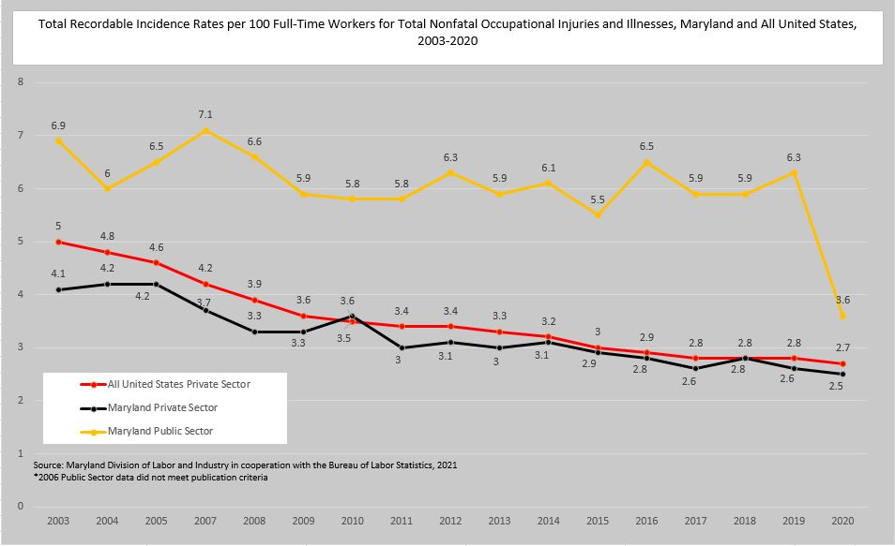

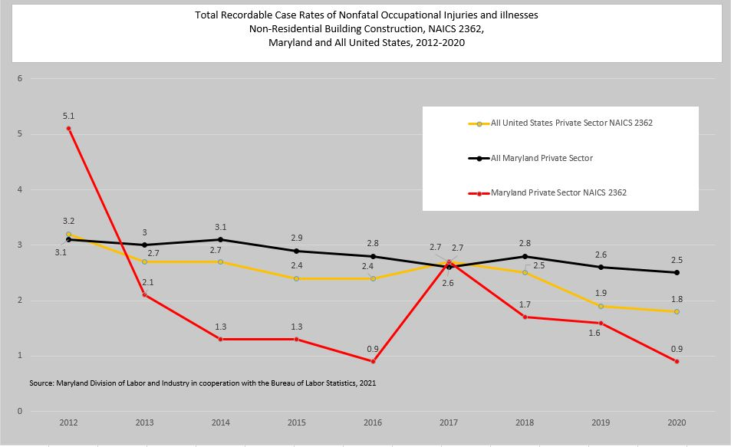

Instructions and Standards Notices

On August 16, 2021, the Joint Committee on Administrative, Executive, and Legislative Review (AELR) granted approval of the Emergency Action submitted by the Commissioner of Labor and Industry to adopt the federal COVID Emergency Temporary Standard (ETS). MOSH adopted the COVID-19 ETS, 29 CFR §1910, Subpart U, which became effective on August 27, 2021. This ETS is focused on protecting healthcare and healthcare support service workers from occupational exposure to COVID-19 in settings where people with COVID-19 are reasonably expected to be present. Please see a copy of this standard notice available online at:
http://labor.maryland.gov/labor/standards/

There were four new MOSH Instructions (MI) issued in FY21. As a result of adopting the COVID-19 ETS, 29 CFR §1910, Subpart U, MOSH developed Pandemic Field Enforcement Guidelines (MI 21-1) and ETS Inspection Procedures (MI 21-2). Additionally, MOSH adopted two federal Occupational Safety and Health Administration (OSHA) National Emphasis Programs (NEP). These were the revised NEP– Coronavirus Disease 2019 (MI 21-3) and the NEP on Amputations in Manufacturing Industries (MI 21-4). The NEPs were adopted in all sections that did not conflict with the MOSH field operations manual (FOM). All MOSH instructions are available online at:
http://labor.maryland.gov/labor/instructions/

V. Special Measures of Effectiveness/Special Accomplishments
Case Highlights - Enforcement
Electrical Room Hazards
On September 9th, 2021, MOSH investigated an electrical shock where an employee suffered severe burns as a result of contacting live switchgear. On the day of the accident, the employees were searching a condominium complex for a location to store cardboard boxes containing pipe insulation. This condominium complex did not restrict electrical rooms to only qualified personnel and the employees entered the electrical room that contained unguarded 7,200-volt primary switchgear for the condominium building. One of the two employees thought the switchgear was old electrical equipment that was not energized and proceeded to reach out and touch the “A” phase of the energized 7,200-volt primary switchgear. At that time, the employee experienced an electrical shock which caused their body to tense, resulting in the employee falling into the “B” phase of the primary switchgear and contacting the energized handle with their head. The employee was taken to the Johns Hopkins Bayview Hospital Burn Unit and treated for injuries to their head and left hand/arm including soft tissue damage requiring multiple surgeries. The inspection found that unqualified employees and condominium owners were provided keys to access these electrical rooms where only qualified personnel would be allowed to enter. The employer was cited for this finding.
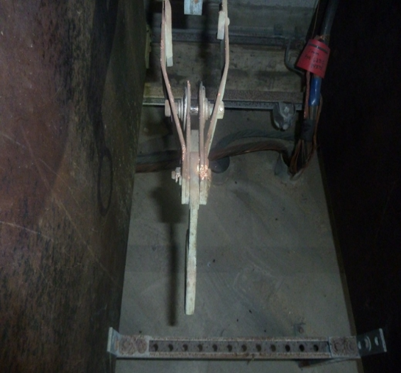
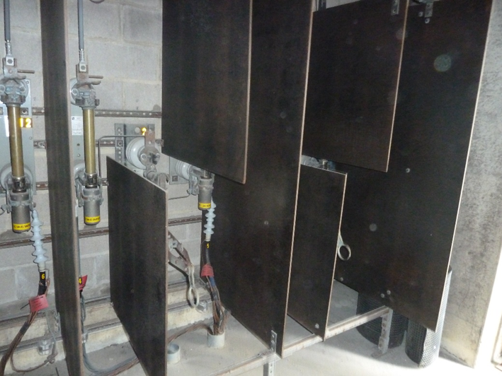
Due to the uniqueness of this incident, MOSH worked with the regional supplier of electricity to this area to identify how common this style and electrical setup is among the property management companies in Ocean City, MD. It was discovered this setup was not uncommon for electrical rooms due to the age and construction of the condominiums. Most of the condominiums were built between 1950 and 1970. The regional power company identified that most of the property managers in Ocean City, MD were members of a regional condominium managers association. MOSH is working on outreach training for the condominium managers association to make condominium managers aware of these hazards that could be present in their electrical rooms to ensure accidents like this one are not repeated.
Education Unit
In FY21, the Training and Education Unit was again affected by the pandemic. In-person seminars were paused for the fiscal year. The Training and Education Unit continued to promote available MOSH safety and health videos on YouTube. These videos reached 2,051 people and were viewed for a total of 33.7 hours. As workplaces resumed in-person activities, MOSH did offer employers the opportunity to request speaking engagements. Compliance officers gave presentations on relevant, technical safety and health topics. In FY21, 8 different employers, institutions, and government agencies requested a MOSH compliance officer to speak at their job site. MOSH speakers spent over 10 hours presenting various safety and health topics to employees. MOSH continues to consider teen safety to be an important topic to cover with high school students who are preparing to enter the workforce. Each year MOSH completes numerous speaker requests at various high schools throughout the state. In FY21, MOSH spent over 6 hours speaking to over 515 students at 5 different events about workplace hazards.
MOSH continues to use and update the Cooperative Partnership webpages to help users easily find information pertaining to specific cooperative programs such as Alliances, Strategic Partnerships (CCP, SPECS), VPP, and SHARP. A “Find a Cooperative Program” webpage was also added to aid employers in determining the right type of cooperative program for their business.
Cooperative Compliance Partnerships (CCP) & Voluntary Protection Program (VPP) - Star Only
The Cooperative Compliance Partnership program is currently going through a reorganization. During this reorganization, two new partnerships were signed in FY21, the CCP program maintained seven sites, and reviewed several others with various general contractors throughout the state of Maryland. The estimated value of these projects totaled over $985M. Several new applications are currently going through the review process and are likely to become new partnerships in FY2022.
Due to the pandemic, no new sites were added to the Voluntary Protection Program FY21. The VPP unit awarded one site re-approval and received one application. Maryland VPP continues to support the OSHA and Voluntary Protection Programs Participants’ Association (VPPPA) Special Government Employee (SGE) program.
Active CCP Sites FY21
Company | Location
Whiting-Turner | The Woodlands at Reid Temple
Whiting-Turner | Kaiser Permanente North Baltimore Medical Center
Whiting-Turner | Easton Elementary
Clark Construction | UMD MS Capital Medical Center
Whiting-Turner | Towson Science Complex
Donohoe Construction | One Light Street
Gilbane | Cole Field House Phase II
Barton Mallow | Morgan State Student Services Building
Whiting-Turner | AA Community College Health and Science Building

Active VPP Sites FY21
Approval Date | STAR Designated Site | Location
11/5/2005 | Performance Pipe | Hagerstown
3/3/2006 | Covanta Energy | Dickerson
11/27/2006 | Monsanto Galena Research Station | Galena
3/12/2007 | Wheelabrator | Baltimore
6/17/2008 | Sherwin Williams | Crisfield
5/25/2009 | Clean Harbors Environmental Services | Baltimore
6/18/2009 | Thermo Fisher Scientific | Frederick
8/15/2011 | Covanta Montgomery Transfer Station | Derwood
3/12/2012 | (Raytheon) Solipsys Corp | Fulton
10/31/2015 | Cintas Corporation 42 | Baltimore
12/29/2015 | Sherwin Williams | Baltimore
3/4/2016 | Cintas Corporation 387 | Frederick
3/4/2016 | Cintas Corporation 41 | Landover
5/5/2016 | Cintas Corporation 393 | Hughesville
5/9/2016 | Raytheon IIS Riverdale | Riverdale
4/2/2018 | Cintas Corporation 386 | Cumberland
4/2/2018 | Cintas Corporation B22 (CRT) | Cumberland
3/26/2019 | NuStar Terminal Baltimore | Baltimore
12/18/2019 | USALCO, LLC | Baltimore
06/06/2012 | GE Healthcare - Maternal Infant Care | Laurel

Strategic Partnership for Excellence in Construction Safety (SPECS)
SPECS is a MOSH strategic partnership agreement signed with the Associated Builders and Contractors, Inc., (ABC). This program maintained activity during FY21 with the following active sites:
Active SPECS Partner Contractors FY21
Company | Location
Coakley-Williams Construction Inc. | Bethesda
Forrester Construction Company | Rockville
Scaffold Resource, LLC | Lanham
Miller & Long Concrete Construction | Bethesda
Gilbane Building Company | Baltimore
Manganaro Midatlantic, LLC | Beltsville
James G. Davis Construction Corp | Rockville

VI. Adjustments or Other Issues
Organizational Changes
During FY21, MOSH added one new industrial hygienist, four safety compliance officers, and one Program Manager focused on Operations and Bureau of Labor Statistics (BLS) reporting.
Staff Training
As MOSH transitioned from primarily telework and remote activities to a full return back to the office, training opportunities were plentiful. New compliance officers leveraged virtual training opportunities to attend OSHA Training Institute (OTI) courses, internal on-the-job training with senior compliance offices in the field was increased, and inspectors were able to attend various safety conferences. MOSH hired a full-time Outreach, Cooperative Compliance Program (CCP), and Voluntary Protection Program (VPP) manager. This new manager will be able to ensure internal and external training opportunities are continued in the next fiscal year for inspectors and the public.

