# MOSH INSTRUCTION:

|  |  |
| --- | --- |
| **INSTRUCTION NUMBER:** 24-3 | **EFFECTIVE DATE:** January 26, 2024 |
| **SUBJECT:** National Emphasis Program on Warehousing and Distribution Center Operations | **ISSUANCE DATE:**  January 26, 2024 |
| **CANCELLATION:** None | **EXPIRATION:** Effective until canceled or superseded |

**Purpose:**

This instruction adopts the federal Occupational Safety and Health Administration (OSHA) National Emphasis Program (NEP) to identify and reduce or eliminate worker exposures to common hazards in warehousing and distribution center operations.

**Scope:**  MOSH-wide

# Reference:

# Current MOSH Field Operations Manual (FOM)

# Occupational Safety and Health Administration Instruction CPL 03-00-026, July 13, 2023, National Emphasis Program on Warehousing and Distribution Center Operations.

1. Appendices A, B, and C of this Instruction.

# Contact: Chief of MOSH Compliance Services.

# See MOSH Website for Current Information https://www.labor.md.gov/labor/mosh

**Background:**

Warehousing and distribution center operations pose a variety of serious safety and health hazards. These include, but are not limited to, struck-by, caught-in between, slips, trips, and fall hazards; blocked aisles; means of egress; powered industrial vehicles and other material handling equipment; heat hazards; and ergonomic hazards. Incidents resulting from the above-mentioned hazards may result in death or serious physical harm. Warehousing and distribution centers have experienced growth from January 2011 to December 2021. The warehousing and distribution centers industry experienced a surge in employment, increasing respectively from 668,900 employed to a total 1,713,900 employed (seasonally adjusted). At the same time the warehousing and distribution center industry has experienced high occupational injuries and illness rates. In the United States, from 2017 through 2021, the incidence rate of nonfatal occupational injuries and illnesses was significantly higher in establishments associated with warehousing and distribution center operations than in all private industry (see Appendix A). This was true for both the total recordable case rate and the rate of cases involving days away from work, restricted activity, or transfer (DART rate). The elevated rates were most pronounced in the subsectors of carriers and express delivery services, general warehousing and distribution, refrigerated warehousing and distribution, and postal service processing and distribution.

This NEP covers warehousing and distribution centers, mail processing and distribution centers, couriers and express delivery services, and local messengers and delivery industries, as well as high-injury-rate retail establishments. The NEP does not cover the U.S. Postal Service processing and distribution centers as federal OSHA has jurisdiction over those facilities in Maryland.

**Action:**

1. With this agency instruction, MOSH adopts OSHA CPL 03-00-026, National Emphasis Program on Warehousing and Distribution Center Operations. In lieu of creating a new site targeting system for warehousing and distribution centers or using data from OSHA’s Injury Tracking Application, MOSH will use its current inspection priority system for general industry, which already encompasses establishments with North American Industry Classification System (NAICS) codes that this NEP covers.
2. In any circumstance where OSHA Directive CPL 03-00-026 may conflict with the current MOSH FOM or this MOSH Instruction, the guidance in the MOSH FOM or Instruction shall prevail.
3. The MOSH Assistant Commissioner shall ensure that operations, compliance, outreach, and consultation personnel utilize this MOSH Instruction.
4. Supervisors shall ensure that this instruction is reviewed with all operations staff, compliance officers, outreach, and consultation staff involved in enforcement or outreach of the NEP.
5. Coding in OSHA Information System (OIS).
   1. For all enforcement and compliance assistance activities in warehouses and distribution centers (i.e., the NAICS covered by this instruction), select “WAREHOUSE23” under National Emphasis Programs on the Inspection tab, in the Inspection Data section.

By and Under the Authority of:



Michael A. Penn CSP, SMS

Acting Assistant Commissioner

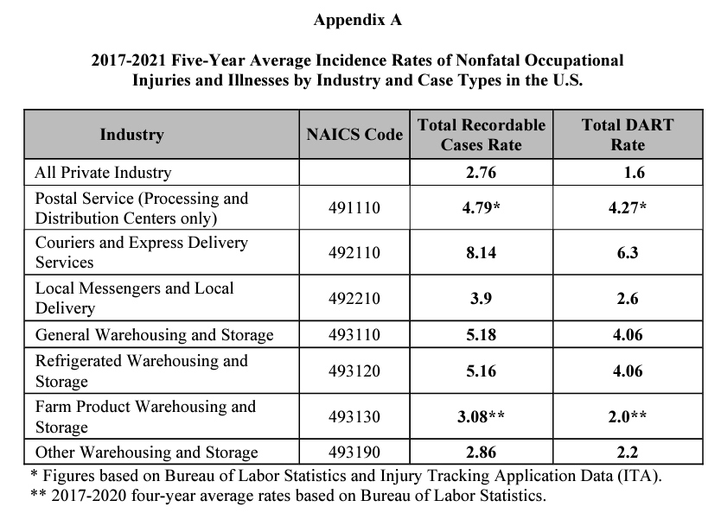

**Appendix B**

**NAICS codes for Warehousing and Distribution Center Operations, Mail/Postal Processing and Distribution Centers, and Parcel Delivery/Courier Services covered under this NEP.** 