FY 2022 State OSHA Annual Report (SOAR): Maryland Occupational Safety and Health

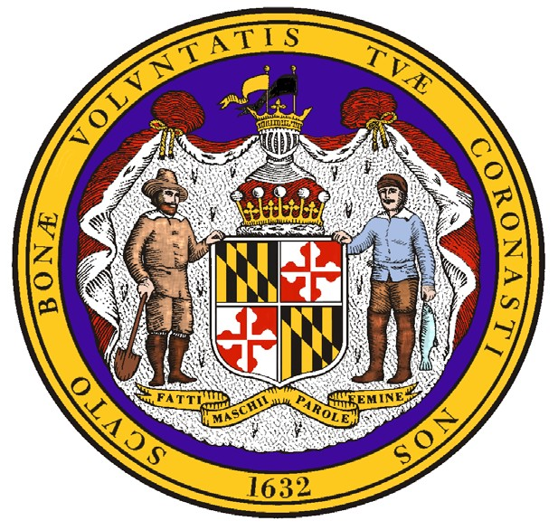
Evaluation Period: October 1, 2021- September 30, 2022 Prepared by: Maryland Occupational Safety and Health Submitted: February 10, 2023

Wes Moore, Governor Portia Wu, Acting Secretary Matthew Helminiak, Commissioner

Table of Contents:

I. | Executive Summary……………………………………………………………………... | 1
II. | Summary of Annual Performance Plan Results………………………………………. | 2
III. | Progress Toward Strategic Plan Accomplishments: Performance & Activity Results | 2
IV. | Mandated Activities……………………………………………………………………... | 8
V. | Special Measures of Effectiveness/Special Accomplishments………………………… | 14
VI. | Adjustments or Other Issues……………………………………………………………. | 18

- Executive Summary

During Fiscal Year 2022 (FY22), Maryland Occupational Safety and Health (MOSH) continued the recovery from the COVID-19 pandemic, which began in March 2020. In response to the many challenges brought on by the pandemic, MOSH staff continued to refine procedures and protocols, identify new technologies, and streamline processes to increase productivity, reduce inefficiency, and eliminate redundancy. MOSH was able to maintain an effective enforcement program, despite operational challenges, including staff turnover.

MOSH developed and successfully refined a method for complainants to file occupational safety and health complaints online. This online complaint form now allows complaints to be directly sent to the Agency, provides new functionality to address confusion regarding the type of complainant and related anonymity, and ensures hazardous conditions are addressed more efficiently. The online form is available in both English and Spanish and can be found at: https://labor.md.gov/MOSHComplaintForm/ComplaintForm.aspx.

MOSH FY22 Overview* :

  - 1,172 safety inspections identifying 5,855 hazards, which resulted in 4,637 citations.
  - 136 health inspections identifying 728 hazards, which resulted in 521 citations.

  - Per compliance inspection, MOSH Compliance Officers and Industrial Hygienists identified an average of 3.05 violations classified as serious, willful, or repeat and 1.99 violations classified as other-than-serious, for a total average of 5.04 violations per inspection.

*Data derived from Appendix D of the FY2022 MOSH Follow-Up Fame Report and Occupational Safety and Health Administration (OSHA) Information System (OIS) reports as of December 1, 2022.

1

I. Summary of Annual Performance Plan Results & III. Progress Toward Strategic Plan Accomplishments

Strategic Goal 1: Improve workplace safety and health through compliance assistance and enforcement of occupational safety and health regulations.
Performance Goal 1.1: Total Reduction in the Fatality Rate by 1% (5% by end of Federal Fiscal Year [FFY] 2022)
Performance Goal 1.2: Reduce the rate of occupational injuries and illnesses in Maryland’s private sector by 1% (5% by end of FFY 2022)
Performance Goal 1.3: Reduce the rate of occupational injuries and illnesses in Maryland’s State and local government sector by 2% (10% by the end of FFY 2022)
Unit Responsible (date source) | Performance Indicator | Result | Comments
Enforcement/ Compliance Assistance  Consultation  OIS Data for various metrics: Bureau of Labor Statistics [BLS] survey of occupational injuries and illnesses | Perform inspection and intervention activity in the following areas:  Industry FY2022 Projected  - Construction (NAICS 23)…… 1053  - Other high-hazard industries… 351  (NAICS 11, 5617, 562, 622-624, 71, 721)  - Public Sector……………………..140  - Manufacturing (NAICS 31-33)…..122  - Trade, Transportation, Utilities…..87 (NAICS 2213, 424, 44-45, 48-49)  Conduct the following number of Consultation visits:  Industry FY2022 Projected  - Construction (NAICS 23)………..See CAPR  - Other high-hazard industries……..See CAPR (NAICS 11, 5617, 562, 622-624, 71, 721)  c. Public Sector…..……..…………...61  - Manufacturing (NAICS 31-33)…..See CAPR  - Trade, Transportation, Utilities…..See CAPR (NAICS 2213, 424, 44-45, 48-49) | Industry 2022 Actual  - Construction (NAICS 23)…… 758  - Other high-hazard industries… 104  (NAICS 11, 5617, 562, 622-624, 71, 721)  - Public Sector……………………..101  - Manufacturing (NAICS 31-33).…111  - Trade, Transportation, Utilities 89  (NAICS 2213, 424, 44-45, 48-49)  Industry 2022 Actual  - Construction (NAICS 23)……..See CAPR  - Other high-hazard industries......See CAPR (NAICS 11, 5617, 562, 622-624, 71, 721)  - Public Sector………………………98  - Manufacturing (NAICS 31-33)….See CAPR  - Trade, Transportation, Utilities….See CAPR (NAICS 2213, 424, 44-45, 48-49) | NOTE: Maryland’s private sector Days Away, Restricted, and Transfer (DART) rate for reference year 2021 was 1.7 injuries and illnesses per 100 full- time equivalent workers; 2020’s rate was 1.6.  MOSH had one 23(g) public sector consultant. All parameters for consultation can be found in the FY22 Consultation Annual Program Report (CAPR).

Strategic Goal 2: Promote a safety and health culture through Cooperative Programs, Compliance Assistance, On-site Consultation Programs, Outreach, Training and Education, and Informative Services.
Performance Goal 2.1: Increase Recognition Programs from 23 to 24 (5 new Recognition programs by end of FFY 2022)
Unit Responsible (data source) | Performance Indicator | Result | Comments
Compliance Assistance (report from consultation unit and Voluntary Protection Program [VPP] unit) | Increase Recognition Programs by 1 new company for FY22. | There were no new sites added for FY22. | MOSH maintained 19 VPP STAR sites.
Performance Goal 2.2: Increase Cooperative Partnerships from 94 to 97 (add 15 new cooperative partnerships by the end of FFY 2022)
Unit Responsible (data source) | Performance Indicator | Result | Comments
Compliance Assistance (report from partnership and alliance unit) | No new cooperative partnerships in FY22. | MOSH did not sign any new partnerships in FY22. | MOSH exceeded the goal laid out in the 5-year strategic plan.
Performance Goal 2.3: Increase Strategic Partnership for Excellence in Construction Safety (SPECS) partnerships from 6 to 9 (add 15 new partnerships by the end of FFY 2022)
Unit Responsible (data source) | Performance Indicator | Result | Comments
Compliance Assistance (report from training and education unit) | Maintain SPECS partnerships at 8. | There were no new SPECS sites added for FY22. | There were no new SPECS sites added for FY22.
Performance Goal 2.4: Maintain attendance in MOSH outreach and training programs annually at 6,000 participants
Unit Responsible (data source) | Performance Indicator | Result | Comments

Compliance Assistance (report from training and education unit) | Number of total attendees for FY22 that attend MOSH training, speaking engagements, and outreach events. | In FY22, the Training and Education Unit continued to be affected by the pandemic and staff turnover. In-person seminars were paused once again for the fiscal year.  The Training and Education Unit continued to promote available MOSH safety and health videos on YouTube. As more workplaces resumed in-person activities, MOSH was able to offer speaking engagements on a wide variety of safety and health topics, including tree care, fall protection, machine guarding, and teen safety. In FY22, more than 20 different employers, institutions, and government agencies requested a MOSH speaker at their job site or event. MOSH speakers spent over 35 hours presenting various safety and health topics to employers, employees, trade, and professional organizations. MOSH continues to respond to numerous requests for teen safety for high school students who are preparing to enter the workforce. In FY22, MOSH spent over 35 hours speaking to almost 700 students at 10 different high school events throughout the state. | The annual goal of 6,000 participants was not met due to lingering COVID-19 concerns and staff turnover. The MOSH Training and Education Unit continues to develop, train, and support senior compliance officers and compliance assistance staff to complete speaker requests and teach seminars. With the new efficiencies gained through COVID-19 response, remote and webinar-based platform learning are replacing in- person learning where appropriate.

Performance Goal 3.1: Percent of fatality and catastrophe inspections initiated within one working day of notification maintained at least 100%
Unit Responsible (data source) | Performance Indicator | Result |  | Comments
Enforcement/ Compliance Assistance (OIS/Integrated Management Information System [IMIS]) | Percentage of fatal case investigations initiated within 1 working day of notification. | According to the 2022 End of Year (EOY) State Activity Mandated Measures (SAMM) Measure 10, MOSH investigated 16 workplace fatalities, all of which were opened within one day of notification. |  | MOSH met its goal of 100% of fatality inspections initiated within one working day of notification.
Performance Goal 3.2: Percent of serious complaint inspections initiated within an average of five days of notification
Unit Responsible (data source) | Performance Indicator | Result |  | Comments
Enforcement/ Compliance Assistance (OIS/IMIS)  SAMM Report | Serious complaint inspections are initiated within an average of 5 days of notification. | In FY22, MOSH initiated complaint inspections within an average of 2.86 days. |  | MOSH maintained complaint tracking and auditing processes that prevented outliers from exceeding 5 days.

Performance Goal 3.3: Percent of discrimination complaint investigations completed within 90 days maintained at least at 90%
Unit Responsible (data source) | Performance Indicator | Result | Comments
Enforcement/ Compliance Assistance (whistleblower web-based application) | Percent of discrimination complaint investigations completed within 90 days. | During FY22, 13 complaints alleging discrimination were administratively closed and 15 were docketed for a full investigation. Of the many challenges MOSH faced this year, MOSH lost its only trained discrimination investigator in FY22. Note: due to implementation of the new Federal Whistleblower application in FY22, annual numbers are not reported by OSHA. | As of Q4, there are now three trained investigators and one supervisor working to eliminate the backlog and improve investigations and efficiency.

Performance Goal 3.4: Achieve overall satisfaction rating of at least 90% of surveyed responses from the MOSH website and Facebook users
Unit Responsible (date source) | Performance Indicator | Result | Comments
Enforcement/ Compliance Assistance  Consultation (online review of website) | This is a continuing Performance Goal carried over from the previous 5-year Strategic Plan, whereas, 90% of website users indicate a positive overall experience when polled at the end of the 5-year Strategic Plan. In 2016 the Department of Labor, Licensing & Regulation (now the Maryland Department of Labor) launched a new website design for all the agencies.  MOSH worked on the layout to keep the website user-friendly and information easy to find. Each unit has its own page where information is provided. We have also added pages for easy access to Employee/Employer Resources, Guidance Documents, and Complaint information. MOSH continues to work towards even better content management and can update the website on a timelier basis. MOSH is still working toward the goal of having a poll online for users to fill out.  Consultation will share in the technical development of the website and continue to maintain their Federal OSHA requirements, current information, and forms. | MOSH continually works to improve and maintain an efficient, useful, and easy to navigate webpage. MOSH is still working toward the goal of having a poll online for users to fill out.  MOSH has also continued to utilize social media links such as the MOSH website, the Department Facebook page, and the State of Maryland YouTube page to keep Maryland employers and employees up to date on the latest safety & health information, educational seminars, and local agency news to inform employees and employers about MOSH’s mission and how Consultation works. | The agency continues to support a user-friendly website. As we move forward we continue to make all of our processes and information easier to find for the final user.  MOSH developed and successfully refined a method for complainants to file occupational safety and health complaints online. This online complaint form now allows complaints to be directly sent to the Agency, provides new functionality to address confusion regarding the type of complainant and related anonymity, and ensures hazardous conditions are addressed more efficiently.

Performance Goal 3.5: 90% of responding employers are satisfied with the consultation visit received
Unit Responsible (data source) | Performance Indicator | Result | Comments
Consultation (returned and completed Maryland Department of Labor [MDOL] external customer survey) | Percent of responding employers that rate “overall satisfaction” as satisfactory or better. | All employer surveys received for public sector activity were rated as “excellent.” Please see the FY22 CAPR for information on private sector activity. | Public sector only activity is captured in this SOAR.
Performance Goal 3.6: Provide prompt consultation service
Unit Responsible (data source) | Performance Indicator | Result | Comments
Consultation (OIS reports) | On average, small high-hazard employers are visited within 30 days of their request for an initial visit; on average, initial visit reports are mailed within 20 days of the closing conference.  Public sector only – see CAPR for private sector. | On average, the initial high-hazard public sector visits were conducted 38 days after their request, and the initial visit reports were mailed 10 days after the closing conference. | Many of the public sector sites are correctional facilities that are understaffed which causes the visit dates to be delayed or rescheduled to a later date.

Program Activity Projections:

Total Inspections- Enforcement
 | Safety |  | Health
 | Projected | Actual | Projected | Actual
Private Sector Inspections | 1215 | 1172 | 162 | 136
Public Sector Inspections | 105 | 85 | 21 | 16
Total | 1320 | 1172 | 183 | 136

Consultation Visits
 | Projected | Actual
21(d) Projected Visits | * | *
23(g) Projected Visits Safety** | 53 | 85
23(g) Projected Visits Health** | 8 | 13

Total Inspections – Consultation

* For results of the 21(d) consultation unit please see the FY21 CAPR
** The number of consultation visits conducted far exceeded the projected numbers. In all, there were 98 23g consultation visits conducted. Safety conducted 72 initial visits and 13 follow-up visits. Health conducted 10 initial and three follow-up visits.

- Mandated Activities

Enforcement
According to the OSHA-derived SAMM report, MOSH Compliance Officers opened 1,308 enforcement inspections in FY22, including 1,172 safety inspections and 136 health inspections. MOSH had projected 1,503 total inspections would be conducted; however, staff turnover contributed to a lower than anticipated number of inspections performed. MOSH lost 12 safety compliance officers and four industrial hygienists in FY22. Despite this, MOSH achieved 87% of its enforcement inspection goal.

Compliance officers continued to focus their efforts on the Maryland industries that have high injury and illness rates. Of the 1,308 enforcement inspections, 967 (74%) were conducted under one or more of the state’s Local Emphasis Programs (LEPs), and 134 (10%) of the inspections were conducted under one or more of the adopted National Emphasis Programs (NEP). MOSH compliance officers investigated 116 accidents, a decrease of 28 from FY21. MOSH investigated 16 workplace fatalities*; all were opened within one day of notification.

*Note: According to the SAMM issued by federal OSHA, MOSH investigated 15 workplace fatalities; upon further review, one additional fatality inspection was identified that was not included in the final end-of-year SAMM report.

For the fourth consecutive year, there were no instances where a Compliance Officer was not able to gain entry to a facility after an employer originally denied the inspection.

End-of-year SAMM data shows MOSH initiated complaint inspections, on average, in 2.86 days, which is within the five-day requirement. Complaint investigations were initiated within an average of 2.58 days, which is within the three-day requirement.

Per SAMM Measure 5, MOSH Compliance Officers and Industrial Hygienists averaged 3.05 serious, willful, or repeat violations and 1.99 other-than-serious violations per case, for a total average of 5.04 violations per case file.

The average penalty per serious violation for all employers was $874.03. MOSH issued an average penalty of $747.00 per serious citation for employers with 25 employees or fewer, $1,046.87 for employers between 26 and 100 employees, $1,616.38 for employers between 101 and 250, and
$1,663.11 for employers with over 250 employees.

Based on the most recent United States (US) Bureau of Labor Statistics (BLS) results for reference year 2021, 41 states, 3 U.S territories, and the District of Columbia, all had publishable state-specific data. Maryland’s private sector total recordable case incidence rate was 2.7 injuries and illnesses per 100 full-time equivalent (FTE) workers, similar to the US private sector’s rate of 2.7.

SAMM Measure 9 shows there were 1,106 qualifying safety inspections completed, with 207 (18.72%) in compliance. There were also 120 qualifying health inspections completed with 31 (25.83%) in compliance.

According to MOSH documentation, 87% of health inspections in FY22 were un-programmed, and 51% were complaint-driven. Just under 8% (7.72%) of all MOSH inspections were completed in the public sector, nearly achieving the FY22 estimated goal of 8% public sector. MOSH continues to use an LEP to help focus on public sector establishments.

Lapse time (number of days from the inspection open date to the citation issuance date) decreased for both safety and health. During FY22, safety inspections averaged 37 days and health inspections averaged 74 days lapse time, a reduction from 47 days and 83 days, respectively, in FY21. This decrease in lapse time continues to reflect the quality control measures implemented to improve the review process, the quality of the case files, and turnaround time. The quality of case files overall continues to improve and they continue to be processed more efficiently than in recent past years.

Consultation- Public Sector
During FY20 and FY21 due to the COVID-19 pandemic, a large number of correctional institution visits were canceled or postponed which resulted in an increase in the number of requests for public sector visits in FY22.

There were 98 public sector visits conducted; 85 safety and 13 health-related, exceeding the goal of 61 visits for FY22. Of the visits conducted, 63% were correctional facility-related while the remaining 47% were conducted in other public service sectors, such as transportation and parks and recreation. The program achieved 160% of its visit goals.

MOSH had one public sector safety consultant in 23(g) for FY22. There were brief intervals when the safety consultant assisted private-sector employers when work was available. When there are specific health concerns on a public sector site, one of the health consultants from the 21(d) program will temporarily transfer to the 23(g) program and perform the health visit.

Consultation supported the Outreach unit by providing consultants to fulfill speaker and seminar presentation requests. All of the public sector requests for service were fulfilled in a timely manner and employer surveys received by the Consultation unit rated the public sector consultant’s service as “excellent.”

Discrimination
The MOSH Discrimination Unit for FY22 experienced turnover with the last remaining discrimination investigator leaving the agency. MOSH used this unique opportunity to reorganize the discrimination unit and solicit investigator assistance outside of MOSH. Three wage claims investigators and one manager from the Division of Labor and Industry Employment Standards Unit began training and conducting discrimination investigations in August of 2022.

In FY22 MOSH received 44 complaints of discrimination. During FY22, 13 complaints alleging discrimination were administratively closed and 15 were docketed for a full investigation under §5- 604 of the Labor and Employment Article, which parallels Section 11(c) of the OSH Act. During FY22, one investigation resulted in a meritorious finding with subsequent relief obtained for the complainant. To ensure continued improvement in case file completion time for the next fiscal year, the unit is currently cross-training staff.

Research and Statistics
In September 2022, the MOSH Research and Statistics unit completed the reference year 2021 data collection for the BLS Survey of Occupational Injuries and Illnesses (SOII) program. The statistics generated from this employer-based survey are the US government’s official accounting of the safety and health issues facing America’s workplaces. The SOII charts the nature and magnitude of occupational injuries and illnesses across the United States. The dedication and perseverance of the Research and Statistics staff helps ensure that MOSH has reliable and timely occupational injury and illness data at its disposal for industry outreach initiatives, targeted enforcement, and
other surveillance purposes. MOSH recently reviewed SOII data and found a continuation that Maryland's nonresidential construction industry consistently reports fewer injuries and illnesses than the national average.

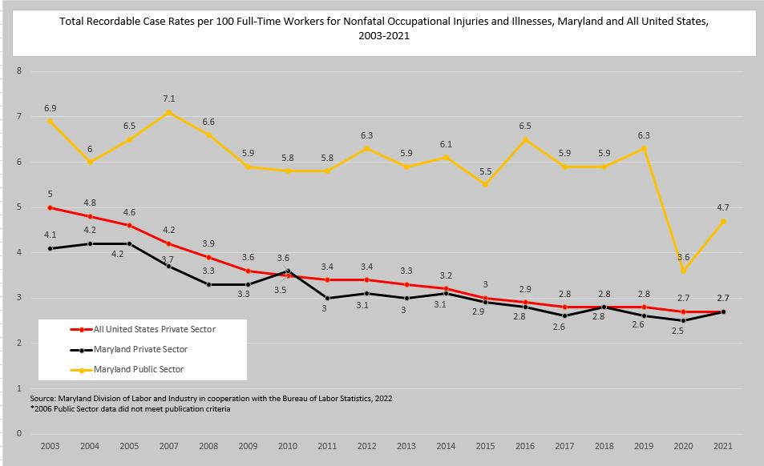

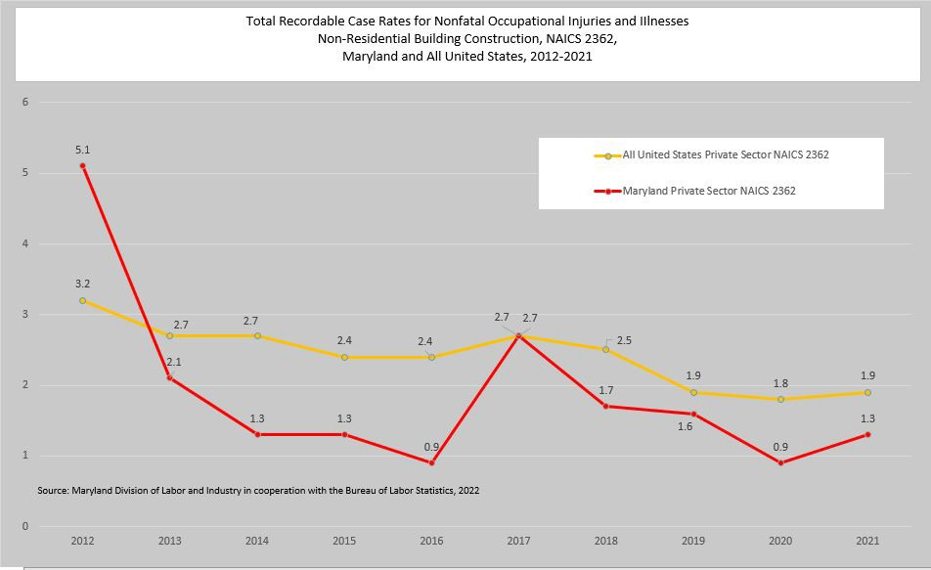

Instructions and Standards Notices
Title 5, Subtitle 12 of the Labor and Employment Article, Annotated Code of Maryland, Chapter 308, Laws of 2020 (House Bill 722) – Heat Stress Standards, requires the Commissioner of Labor and Industry, in consultation with the MOSH Advisory Board, to develop and adopt regulations by October 1, 2022, to require employers to protect employees from heat-related stress in the workplace. In accordance with Ch. 308, MOSH hosted four regional informational sessions and reviewed public comments. Proposed regulations were presented at a public MOSH Advisory Board Meeting on August 23, 2022, and unanimously supported by the Board, who commended the agency for its balanced and enforceable approach.
A proposed regulation was published in the Maryland Register on October 7, 2022. The 30-day comment period expired on November 7, 2022, during which 37 comments were received. The proposed regulations are currently under a hold for final promulgation by the Maryland Joint Committee on Administrative, Executive, and Legislative Review (AELR) committee for additional review time.

On August 16, 2021, the Maryland Joint Committee on AELR granted approval of the Emergency Action submitted by the Commissioner of Labor and Industry to adopt the federal COVID Emergency Temporary Standard without substantive amendment. This action was published in the Maryland Register on August 27, 2021, Volume 48, Issue 18 [21-121-E]. http://www.dsd.state.md.us/comar/SubtitleSearch.aspx?search=09.12.29.*
This action expired on January 30, 2022.

MOSH issued one new instruction in FY22, adopting OSHA Instruction CSP 02.00.004 Consultation Policies and Procedures Manual. Adoption of "OSHA Instruction CSP 02-00-004, Consultation Policies and Procedures Manual.” All MOSH instructions are available online at:
http://labor.maryland.gov/labor/instructions/

Special Measures of Effectiveness/Special Accomplishments

Case Highlights - Enforcement
Wastewater Processing Facility Fire and Fatality
On March 7, 2022, MOSH was notified of an industrial fire and fatality at a wastewater processing facility in the Baltimore neighborhood of Curtis Bay, located on the south side of Baltimore City. Upon initial inspection, the employer claimed to process “only water”, and was unsure of the cause of the fire. MOSH visited the facility multiple times, interviewed witnesses, and conversed with officials at the Maryland Department of the Environment (MDE) and Environmental Protection Agency (EPA). The investigation revealed that one employee had been emptying wastewater from a tanker truck into a 6,000-gallon, single-walled, high-density polyethylene processing tank using a Honda trash pump. When the contents of the processing tank began to overflow, the employee unloading the tanker ran to shut off the pump and a fire erupted, quickly engulfing him and spreading to the rest of the exterior holding tanks of the facility. Co-workers were unable to extinguish the flames on the victim and the employee succumbed to his injuries.
MOSH concluded that the wastewater in the processing tanks contained varying layers of petroleum products, including oil, gasoline, and diesel fuel which are lighter than water and had floated to the top of the tanks. The autoignition temperatures of these materials are as low as 477 degrees Fahrenheit. When Tank 2 began to overflow near the trash pump, the overflowing liquid contained mostly petroleum products. The flammable material spilled onto the employee while he was attempting to shut off the adjacent trash pump. The material ignited, either by the hot engine or the backfire of the muffler as the employee attempted to shut off the pump, catalyzing a large, rapidly-spreading petroleum fire. The fire, which required foam to extinguish, resulted in the death of one employee, the destruction of 13 storage tanks, and damage to several buildings. MOSH issued citations for violations related to sources of ignition and storage of flammable liquids, confined space, hazard communication, and respiratory protection.

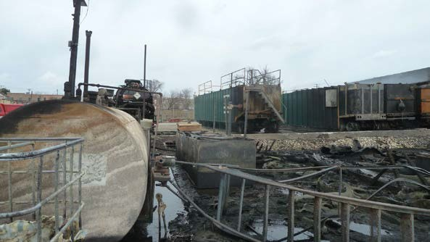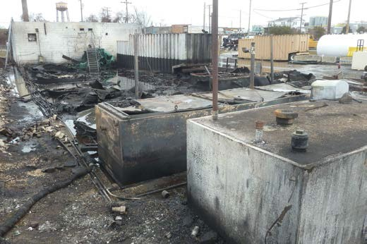

Fire Service Fatalities

On January 24, 2022, MOSH was alerted that two firefighters were fatally injured, a third had sustained severe injuries, and a fourth was still missing in a structure collapse where firefighters were responding to a dwelling fire with reports of people trapped in a vacant row home in the Mount Clare neighborhood of southwest Baltimore City. MOSH inspectors conducted a thorough investigation including review of all relevant data and documents, interviews with the employer, employees, union representatives, other interested parties, and discussion with in- house counsel. MOSH identified several concerns relative to the resulting fatalities and department incident response overall, such as: emergency response of this and similar, previous incidents entering vacant structures; the history and identification of vacant, unoccupied structures in Baltimore City; and, fire service “culture” surrounding entry into structures with unconfirmed occupants. MOSH issued a hazard alert letter and recommended the following steps, or their equivalent, be taken in an effort to eliminate or reduce the hazards associated with fighting fires in unoccupied structures:

  - Implement Departmental Order 102-10, dated November 30, 2010, and titled “Unsafe Vacant Buildings” or a similar policy. The purpose of the order [to reduce the risk to firefighters from injury and death caused by the serious known threats associated with unsafe vacant buildings] was a pilot program and required certain Fire Departments to attach placards to mark vacant buildings that are unsafe for interior firefighting purposes. A universal marking/placarding system with detailed instructions [shall] be utilized along with a periodic reconciliation exercise to ensure unsafe vacant structures remain marked and structures are added or removed based on current conditions. A database of the vacant or unsafe buildings that are marked should be maintained. Units responding to fires in buildings marked/placarded in accordance with Departmental Order 102-10, or similar, shall immediately notify Fire Communications of the structure’s designation [prior to entry]. Fire Communications shall immediately alert all responding units that a structure is designated as an Unsafe Vacant Building when the information is provided from the database or premise file.
  - Develop and enforce a policy that prohibits firefighters from entering unoccupied structures that are on fire absent express approval from command staff, which may include but is not limited to:
When responding to a fire at an unoccupied structure, units are to use EXTERIOR OPERATIONS ONLY or other means that eliminate the exposure of firefighters to the hazards associated with structural collapse unless otherwise directed by the Incident Commander after considering the site conditions and the risk to subordinate firefighters. If a determination is made to override exterior operations only, communication of the decision and concurrence by the next higher-ranking fire official through Fire Communications shall be made. The Department shall initiate an operating policy that provides that no firefighter enters an unoccupied dwelling where heavy fire is showing from two or more floors upon their arrival unless the firefighter has credible firsthand knowledge that someone is in the structure.

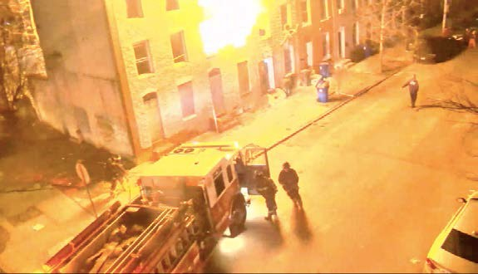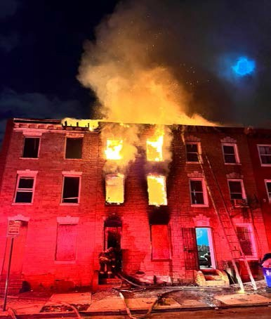

* Photos courtesy of Baltimore City Fire Department.

Education Unit
In FY22, the Training and Education Unit continued to be affected by the pandemic and staff turnover. In-person seminars were paused once again for the fiscal year.
As more workplaces resumed in-person activities, MOSH was able to offer speaking engagements on a wide variety of safety and health topics, including tree care, fall protection, machine guarding, and teen safety. In FY22, more than 20 different employers, institutions, and government agencies requested a MOSH speaker at their job site or event. MOSH speakers spent over 35 hours presenting various safety and health topics to employers, employees, trade and professional organizations. MOSH continues to respond to numerous requests for teen safety for high school students who are preparing to enter the workforce. In FY22, MOSH spent over 35 hours speaking to almost 700 students at 10 different high school events throughout the state.

Staff Training
In FY22, compliance officers were able to take advantage of training opportunities to attend both in- person and virtual OSHA Training Institute (OTI) courses, engage in internal on-the-job training with senior compliance offices in the field, and attend safety conferences.
MOSH also restarted in-house training of 13 new and junior safety and health compliance officers toward the end of FY22. A total of 14 training classes were offered or scheduled for the last part of FY22 and first quarter of FY23 and included topics covering most of the 29 CFR 1926 Construction Subparts, as well as equipment use and inspection procedures. MOSH personnel, including veteran compliance safety and health officers and consultants, supervisors, and managers provided the training which included classroom and hands-on practical instruction, and evaluation.

Cooperative Compliance Partnerships (CCP) & Voluntary Protection Program (VPP) - Star Only
The Cooperative Compliance Partnership program continued its reorganization phase in FY22. The CCP program added one new site, Port Covington, and reviewed several others with various general contractors throughout the state of Maryland. Several new applications are currently going through the review process and are likely to become new partnerships in FY23.
Due to staff turnover at the management level and compounded by the ongoing COVID pandemic, renewal inspections were completed, but no new sites were added to the Voluntary Protection Program FY22. Maryland VPP continues to support the OSHA and Voluntary Protection Programs Participants’ Association (VPPPA) and Special Government Employee (SGE) program.

Active VPP Sites FY22
Approval Date | STAR Designated Site | Location
11/5/2005 | Performance Pipe | Hagerstown
3/3/2006 | Covanta Energy | Dickerson
11/27/2006 | Monsanto Galena Research Station | Galena
3/12/2007 | Wheelabrator | Baltimore
6/17/2008 | Sherwin Williams Specialty Region | Crisfield
5/25/2009 | Clean Harbors Environmental Services | Baltimore
6/18/2009 | Thermo Fisher Scientific | Frederick
8/15/2011 | Covanta Montgomery Transfer Station | Derwood
3/12/2012 | (Raytheon) Solipsys Corp | Fulton
10/31/2015 | Cintas Corporation 42 | Baltimore
12/29/2015 | Sherwin Williams | Baltimore
3/4/2016 | Cintas Corporation 387 | Frederick
3/4/2016 | Cintas Corporation 41 | Landover
5/5/2016 | Cintas Corporation 393 | Hughesville
5/9/2016 | Raytheon IIS Riverdale | Riverdale
4/2/2018 | Cintas Corporation 386 | Cumberland

4/2/2018 | Cintas Corporation B22 (CRT) | Cumberland
3/26/2019 | Sunoco LP (fka NuStar Terminal) Baltimore | Baltimore
12/18/2019 | USALCO, LLC | Baltimore

Strategic Partnership for Excellence in Construction Safety (SPECS)
SPECS is a pilot MOSH strategic partnership agreement signed with the Associated Builders and Contractors, Inc. (ABC). This program did not add any additional active sites during FY22 due to staffing shortages and other free and available resources offered during this transitional time period.

Adjustments or Other Issues

Organizational Changes
During FY22, MOSH lost four industrial hygienists, 12 safety compliance officers, two program managers, and several administrative staff members. MOSH added two industrial hygienists and eight safety compliance officers. Additionally, MOSH reorganized Administration and Operations units to improve workflow efficiency and effectiveness. One regional supervisor was promoted to the Assistant Chief of Safety in an acting capacity to assist the Chief of Compliance and regional supervisors in meeting agency goals. MOSH hired one administrative specialist to serve as the Coordinator of Outreach and Training. The Chief of Compliance is currently the Acting Assistant Commissioner and MOSH named a new Program Director in FY22.

