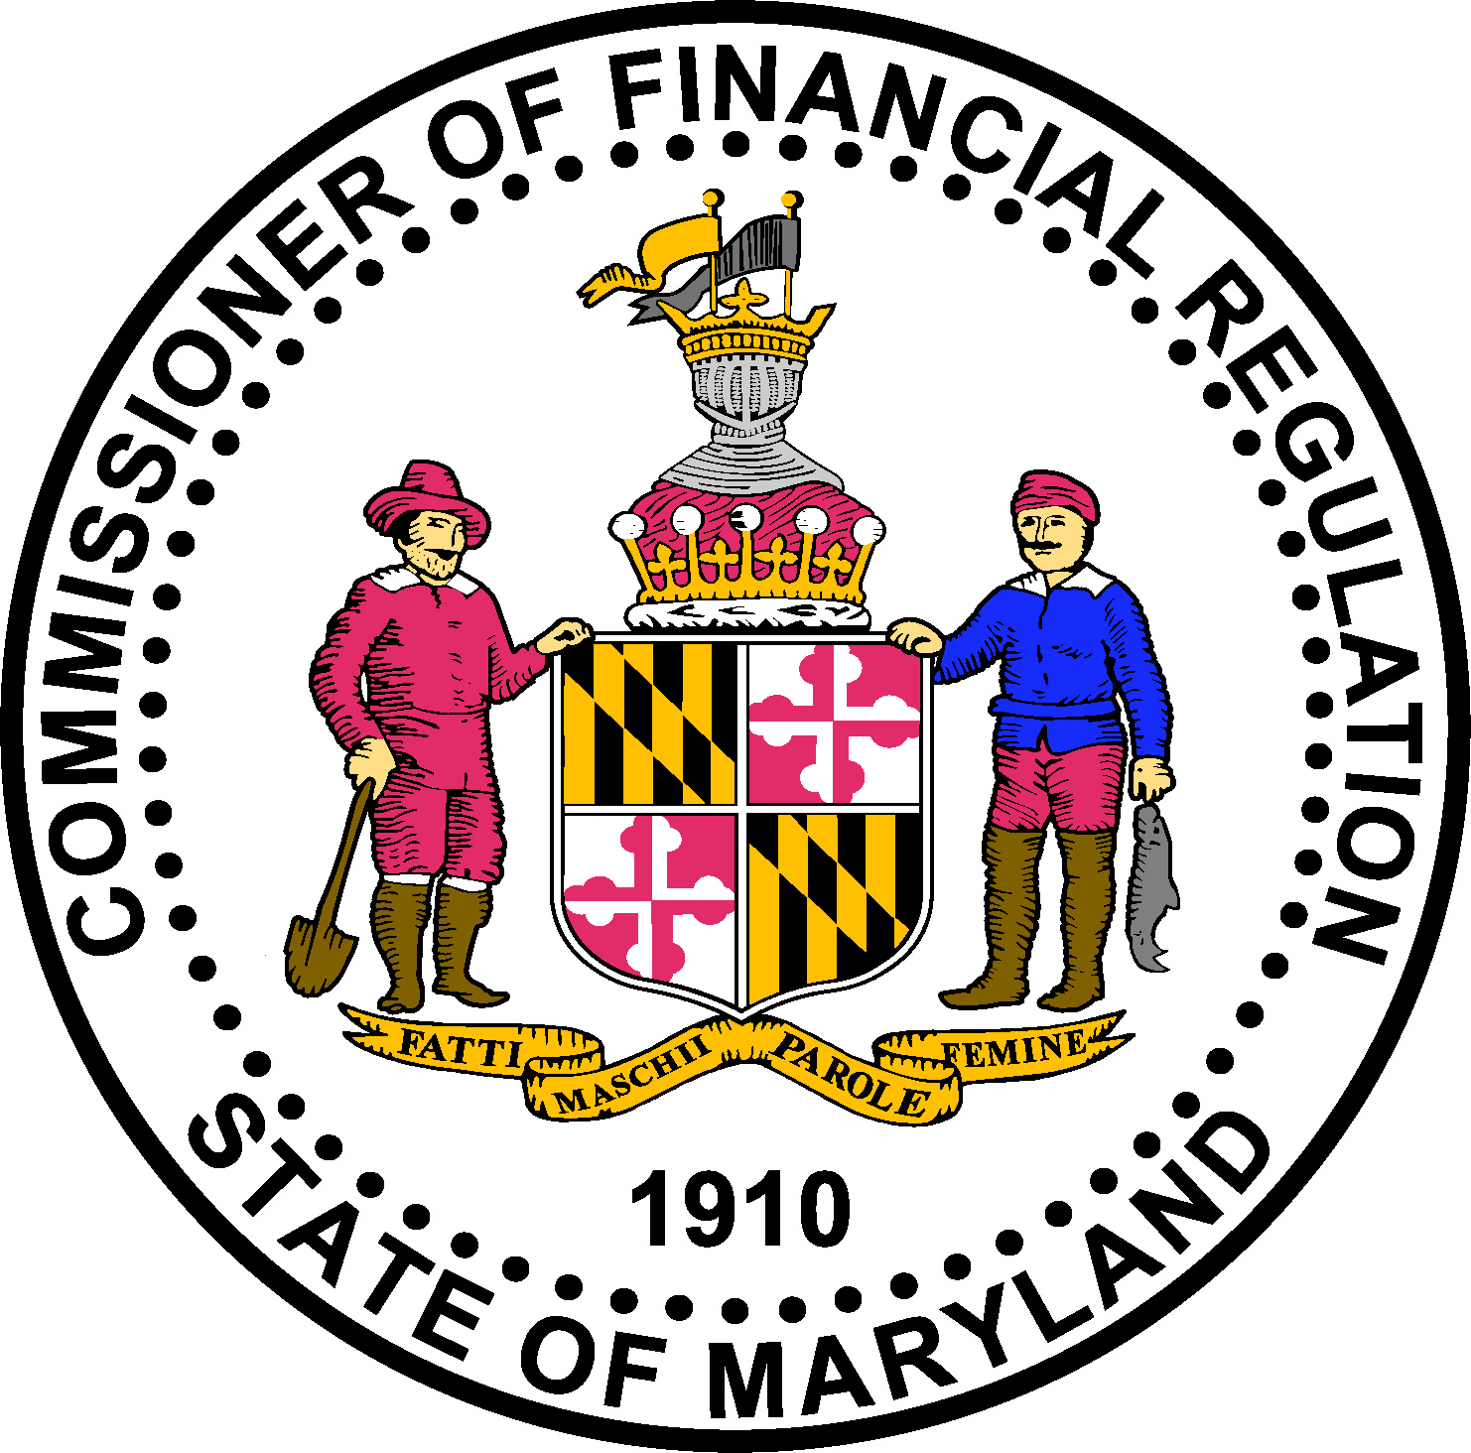

Maryland COLLECTION AGENCY

New Branch Application CHECKLIST

LEGAL REQUIREMENTS: Refer to Md. Code Ann., Bus. Reg., Title 7 or contact legal counsel.

APPLICATION PROCESS: This document includes instructions for a new collection agency branch license request via the Office of the Commissioner of Financial Regulation (“Commissioner”) website at: http://www.dllr.state.md.us/finance/industry/collag.shtml. If you need to complete a new application for a company location (principal executive office location) refer to the appropriate new application checklist.

Note: The company (principal executive office location) must submit a new application form (or be in an approved-status) prior to the submission of a new branch application.

Additionally, if you have more than one location, you must submit a separate application for each location.

Please note that the Commissioner must receive (at the address below) the information marked “Attached” on the checklist within five (5) business days of the electronic submission of your application:

For U.S. Postal Service or Overnight Delivery

Maryland Commissioner of Financial Regulation
Attn: Licensing Unit
500 N Calvert Street, Suite 402
Baltimore, Maryland 21202

INCOMPLETE APPLICATION: If your application package is incomplete (including explanations and/or required documentation submitted in an incorrect format) sixty (60) days after the application filing, the Commissioner may terminate the processing of the application and will deem the incomplete application withdrawn by the applicant.

LICENSE FEE: The 2-year non-refundable licensing fee of $700.00 is prorated based on the application’s date compared to the time remaining until the expiration date (licenses are biannual and expire at calendar year-end or 12/31). For example, licenses issued in 2016 and 2017 will expire on 12/31/17. An applicant who applies for a license on March 31, 2017 will pay $262.50 or 37.5% of the $700 biannual licensing fee.

Registration Number: ________________

Applicant Legal Name: ______________________________________
Attached | Not applicable | Maryland Collection agency COMPANY License
□ | □ | Surety Bond ($5,000 per collection agency license):  - The bond must be completed on the form posted on the Commissioner’s website (see: http://www.dllr.state.md.us/finance/industry/collag.shtml);  - The insured’s name and address must match exactly the applicant’s full legal name and address; and  - The surety bond company must be licensed to conduct business in Maryland. Confirm the bond company is licensed by doing a quick search on the Maryland Insurance Administration website: http://www.mdinsurance.state.md.us/iq/jsp/interactiveQuery/CompanySearch.jsp?mode=true.
□ | □ | applicatION fee: Non-refundable license fee paid by:  Credit Card fee was paid on _____________ [Date].  Or  Check was mailed with invoice on _____________ [Date] to:  Maryland Commissioner of Financial Regulation  P.O. Box 17409  Baltimore, Maryland 21297-1409

WHOM TO CONTACT – Contact the Commissioner of Financial Regulation licensing staff by phone at 410-230-6155 or 888-784-0136 for further assistance regarding Maryland specific requirements.
THE APPLICANT/LICENSEE IS FULLY RESPONSIBLE FOR ALL OF THE REQUIREMENTS OF THE LICENSE FOR WHICH APPLICANT/LICENSEE IS APPLYING. THE SPECIFIC REQUIREMENTS CONTAINED HEREIN ARE FOR GUIDANCE ONLY. SHOULD YOU HAVE QUESTIONS, PLEASE CONSULT LEGAL COUNSEL.

