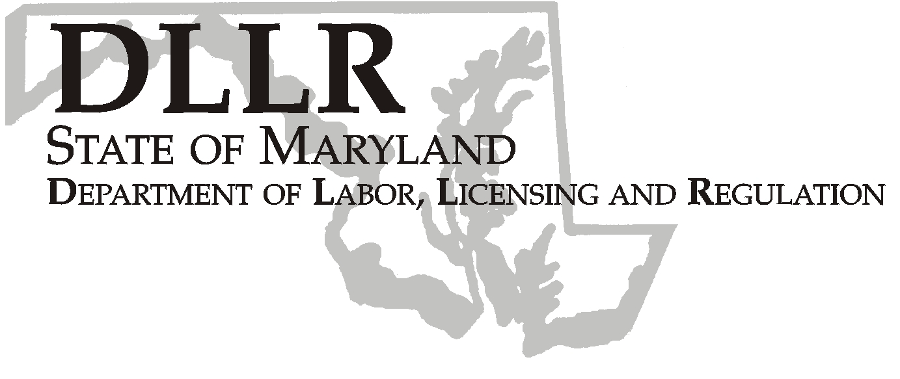
MARTIN O’MALLEY, Governor
ANTHONY G. BROWN, Lt. Governor
THOMAS E. PEREZ, Secretary

Andrew Moser, Assistant Secretary

Division of Workforce Development

DLLR Home Page • http://www.dllr.state.md.us
E-mail • amoser@dllr.state.md.us

PHONE: 410-767-2997 FAX: 410-333-5355
TTY USERS, CALL VIA THE MD RELAY SERVICE

1100 NORTH EUTAW STREET . ROOM 616
BALTIMORE, MD, 21201

Keeping Maryland Working and Safe

WORKFORCE INVESTMENT FIELD INSTRUCTION (WIFI) No. 11-06

DATE: May 7, 2007

TO: Maryland Workforce Investment Act (WIA) Grant Recipients

SUBJECT: Maryland Summer Youth Connection Fiscal Year 2008

REFERENCES: None

BACKGROUND INFORMATION:

Governor Martin O’Malley included $250,000 in the State Fiscal Year 2008 budget for the Department of Labor, Licensing and Regulation (DLLR) to operate a Fiscal Year 2008 Summer Youth Program. These funds will be awarded to local Workforce Investment Areas (LWIAs), using the federal WIA formula allocation methodology. LWIAs will be responsible for providing summer employment opportunities for youth within the parameters outlined by DLLR.

ACTION TO BE TAKEN:

Local Workforce Investment Areas must follow the attached guidelines and procedures for requesting these funds, and incorporate the attached funding amount in their grant requests.

CONTACT: Valerie Myers (410) 767-2825 or vmyers@dllr.state.md.us

EFFECTIVE: May 7, 2007

Andrew Moser
Assistant Secretary

Division of Workforce Development

FY’08 MARYLAND SUMMER YOUTH CONNECTION PROGRAM GUIDELINES

The Maryland Summer Youth Connection Program will primarily serve youth who are 14 and 15 years old and who are low-income, have a disability or a special need. The funds may be used to develop, match, monitor and evaluate job placement of eligible youth. Additionally, these funds may be used as an incentive or match to encourage the private sector to hire eligible youth during the summer months.

A local area’s allowable program costs include wages paid to participants, supervision and training, materials and supplies related to the work provided, reasonable transportation costs and other administrative costs. Participating youth must not be paid less than the state minimum wage of $6.15 per hour.

Requirements

The local workforce investment areas must:

- Develop meaningful and well-supervised work experiences for youth in the program,
- Provide activities to enhance job skills and career-exposure,
- Submit a narrative to DLLR detailing the local area’s plan for summer activities, including a Statement of Planned Outcomes for the program. This statement will include targeted outcomes such as: number of job placements, number of program completers, and number of enhancement activities (resume development, interview techniques, career exposure, etc.), and
- Complete an end-of-summer report by October 15, 2007 that includes the number of youth served, age group of youth served, activities provided and an accounting of expenditures.

These funds must be expended between July 1, 2007 and September 30, 2007 for authorized activities only. If you are unable to accept your allocation, (see attached chart), please contact Ms. Dorothee Norton no later than May 31, 2007

In order to receive these funds, you must submit the following to Ms. Dorothee Norton by July 1, 2007:

- Two signed original WIA Signature Sheets
- Program Narrative which includes the above requirements

Summer Youth Connection

FY 2008 Allocations

ANNE ARUNDEL | $7,112
BALTO CITY | $92,354
BALTIMORE | $32,817
FREDERICK | $3,335
LOWER SHORE | $14,899
MID-MARYLAND | $2,727
MONTGOMERY | $9,518
PRINCE GEORGE'S | $49,963
SOUTHERN MD | $3,216
SUSQUEHANNA | $11,187
UPPER SHORE | $5,998
WESTERN MD | $16,873
TOTALS | $250,000

Summer Youth Connection

FY 2008 Allocations

ANNE ARUNDEL | $7,112
BALTO CITY | $92,354
BALTIMORE | $32,817
FREDERICK | $3,335
LOWER SHORE | $14,899
MID-MARYLAND | $2,727
MONTGOMERY | $9,518
PRINCE GEORGE'S | $49,963
SOUTHERN MD | $3,216
SUSQUEHANNA | $11,187
UPPER SHORE | $5,998
WESTERN MD | $16,873
TOTALS | $250,000

