Bureau of Labor Statistics’ Census of Fatal Occupational Injuries (CFOI) Program

The Maryland Census of Fatal Occupational Injuries (CFOI) program collects and publishes statistics on all fatal occupationally related injuries that occur in the State of Maryland. CFOI is conducted within the Maryland Department of Labor, Licensing and Regulation, Division of Labor and Industry in cooperation with the U.S Department of Labor, Bureau of Labor Statistics.

Preliminary results for the CFOI program, Maryland, 2013

Fatal work injuries in Maryland totaled 78, according to the preliminary results. This count represented an 8 percent increase from 2012’s final tally of 72. A number of these fatal events, however, were not under MOSH’s jurisdiction, including cases of workplace homicide, accounting for 12 percent of the total and transportation roadway incidents, accounting for 9 percent. Fatal occupational injuries in Maryland have ranged from a high of 106 cases reported in 2006 to a low of 60 cases reported in 2008. Final fatality numbers for Maryland, as well as the nation, will be released in April 2015.

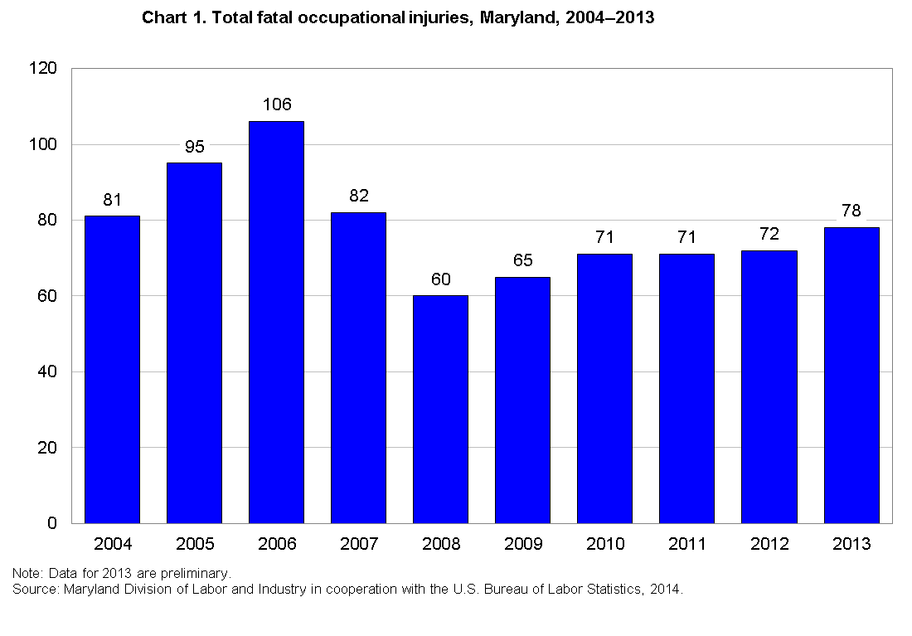

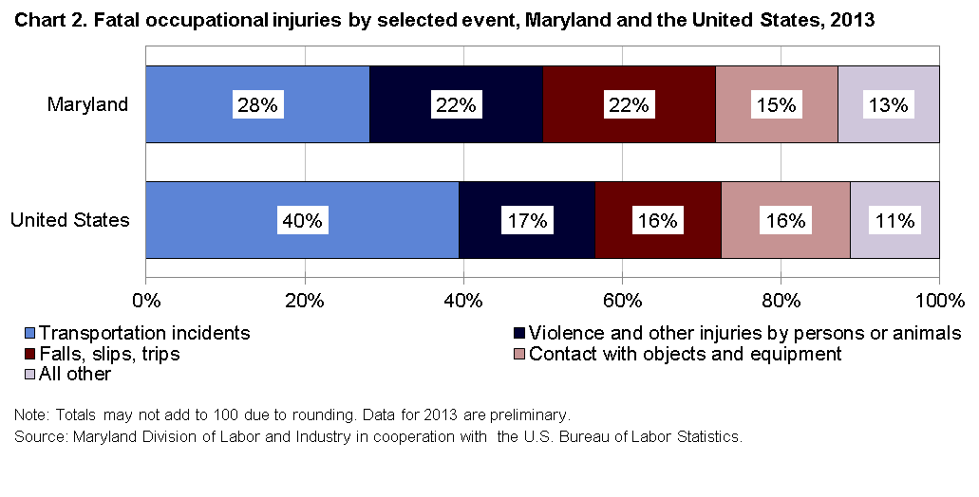

Highlights from the Maryland Census of Fatal Occupational Injuries, 2013

- With 22 workplace fatalities, representing 28 percent of the total count, transportation related incidents were the leading cause of death to workers in the State of Maryland in 2013, as they have been every year since 1996.

- Half of the transportation incidents (11 cases) were pedestrian-vehicular events where the worker was struck by a vehicle either in, or on the side of the roadway. Four of these cases occurred within a construction work zone. Seven of the transportation incidents involved highway crashes between vehicles such as a when a truck driver loses control of his vehicle and crosses the line into oncoming traffic.

- Both falls, slips or trips, and violence and other injuries by persons or animals, were the second most frequently occurring events, each with 17 reported cases. Of the fatal injuries due to falls, 14 of the cases involved falls to a lower level.

- The government sector, which includes federal, state, and local government employment experienced the most fatalities in the State with 19 reported cases. Ten of the cases involved federal workers, while 8 occurred in local government and one in State government.

- Of the 8 local government fatalities, 3 workers were killed after being struck by an object or piece of equipment; two firefighters were killed, one from fire, another in a pedestrian-vehicle accident. Two officers in police protection lost their lives, one from homicide, and one from suicide. The remaining case did not meet publication criteria.

- Slightly over three-quarters of the fatalities, (59 cases) occurred in private industry with service-providing industries accounting for 59 percent (35 cases) and goods-producing industries accounting for 41 percent (24 cases). Based on Maryland DLLR employment data, goods-producing industries accounted for roughly 13 percent of the State’s private sector employment in 2013.

- The construction sector, with 18 reported cases, had the highest fatality count in the private sector. With 146,000 employees, construction represented 7 percent of private sector employment.

- Within the construction sector, specialty trade contractors (NAICS 238) accounted for 10 of the work-related deaths, and of these, 7 occurred with foundation, structure, and building exterior contractors (NAICS 2381).

- Similarly with the 2013 national results, falls, slips and trips was the primary cause of death in the construction sector with 6 reported cases in Maryland; one fewer than the 7 reported in 2012.

- Men accounted for all 18 of Maryland’s construction fatalities and half involved Hispanic or Latino workers.

- Fatalities in the transportation and warehousing sector (NAICS 48-49) declined by more than half from 12 reported cases in 2012 down to 5 fatalities in 2013. General freight trucking, long distance (NAICS 48412) accounted for 3 of the 5 cases. Transportation and warehousing reported 11 deaths in 2011 and 9 in 2010.

- Six workers were killed while employed in the accommodation and food services sector (NAICS 72). Of these, 5 worked in food services and drinking places (NAICS 722).

- White, non-Hispanic workers accounted for 55 percent of the fatalities in Maryland, while nationally this group accounted for 68 percent; black, non-Hispanic workers accounted for just under one-quarter of the deaths in the State, while blacks accounted for 9 percent of the nation’s total. Hispanic or Latino workers accounted for 18 percent of the deaths in Maryland as well as the nation.

- Workers born in the United States accounted for 73 percent (57 cases) of Maryland’s fatality count. Of the 21 workers of foreign-born descent, 43 percent came from El Salvador.

- Men accounted for 95 percent of the State’s fatality count. Their proportion of the total was up from 91 percent in 2012. The primary manner in which the fatal injury occurred for men was a transportation incident with 22 cases, while violence and other injuries by persons or animals and falls, slips or trips accounted for 16 cases each.

- Based on employment status, just under 80 percent of the decedents (62 cases) worked for wages or salaries while the remaining 16 were self-employed. The most frequent manner in which a wage and salary worker was killed was a transportation incident (20 cases) while falls, slips or trips (6 cases) was the most frequent fatal event for the self-employed.

- The construction and extraction occupations had the highest number of fatalities with 17 cases. Over one-third of these fatal events were the result of falls, slips, or trips.

- Transportation and material moving occupations had the next highest count with 14 cases. Eight of these cases involved either vehicle highway crashes or workers struck by vehicles alongside, or in the road. Some of the more detailed occupations in this category were bus drivers, driver/sales workers, tractor-trailer drivers and taxi drivers.

The Baltimore-Towson, Maryland Metropolitan Statistical Area

- Representing 45 percent of the State’s total fatality count, 35 fatalities occurred in the Baltimore-Towson, Maryland Metropolitan Statistical Area which includes Anne Arundel, Baltimore, Carroll, Harford, Howard, and Queen Anne’s Counties, as well as Baltimore City.

- Transportation incidents and violence and other injuries by persons or animals, were the two most frequent events in the Baltimore-Towson Metropolitan Statistical Area in 2013, each with 9 reported cases. Together these two events accounted for 51 percent of the total.

- Of the 9 transportation related events, 5 cases involved pedestrian-vehicle incidents with 2 of the workers killed in construction work-zones.

- Contact with objects and equipment and falls, slips and trips were the next most frequently occurring events, both recording 6 six cases each. Contact with objects and equipment included one worker killed in an excavation or trenching cave-in; another employee caught between a rolling powered vehicle and another object; and one employee caught in running machinery during regular operation.

Chart 3, Total fatal occupational injuries, Baltimore-Towson Metro Statistical Area, 2004-2013
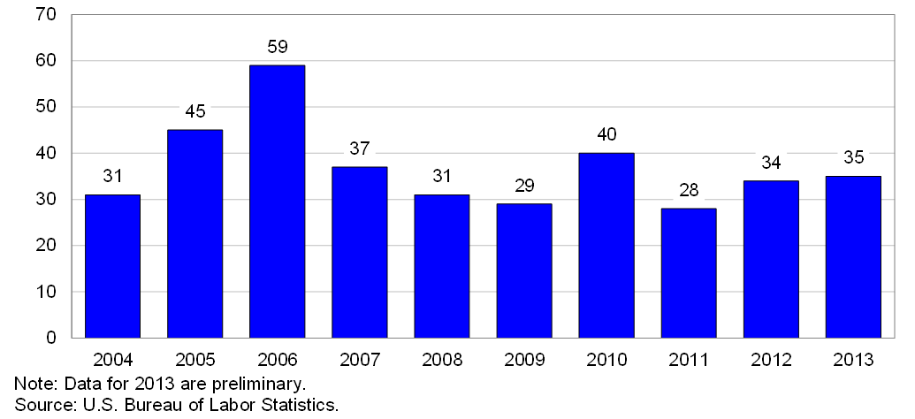

Scope and Program Technical Notes

The Maryland CFOI program compiles a complete accounting of all fatal work injures occurring in Maryland during the calendar year. The program uses diverse data sources from a variety of federal, state and local government administrative records in order to substantiate and then profile fatal work injuries. CFOI includes data for all workplace fatalities regardless of whether the fatality was under the regulatory authority of the Maryland Occupational Safety and Health agency or other federal and state agencies. Therefore, any comparison between the CFOI program’s census counts and those released by other agencies or sources should take into account the different scopes of coverage and definitions being used.

For a fatality to be included in the census, the decedent must have been employed (that is working for pay, compensation, or profit) at the time of the event, engaged in a legal work activity, or present at the site of the incident as a requirement of his or her job. Fatalities to volunteers and unpaid family workers who perform the same duties and functions as paid workers are also included in the count. These criteria are generally broader than those used by State and federal agencies administering specific laws and regulations. (Fatalities that occur during a person’s normal commute to or from work are excluded from the census counts.)
Data presented in this release include deaths occurring in 2013 that resulted from traumatic occupational injuries. An injury is defined as any wound or damage to the body resulting from acute exposure to energy, such as heat, electricity, or impact from a crash or fall, or from the absence of such essentials as heat or oxygen, caused by a specific event or incident within a single workday or shift. Included are open wounds, intracranial and internal injuries, heatstroke, hypothermia, asphyxiation, acute poisonings resulting from short-term exposures limited to the worker’s shift, suicides and homicides, and work injuries listed as underlying or contributory causes of death.

Table 1. Fatal occupational injuries by event or exposure, Maryland, 2012-2013
Event or exposure¹ |  | 2012² |  | 2013p
 |  | Number |  | Number | Percent
Total |  | 72 |  | 78 | 100
Violence and other injuries by persons or animals |  | 15 |  | 17 | 22
Intentional injury by person |  | 12 |  | 16 | 21
Homicides |  | 5 |  | 9 | 12
Shooting by other person--intentional |  | 4 |  | 6 | 8
Stabbing, cutting, slashing, piercing |  | 1 |  | 1 | 1
Bombing, arson |  | - |  | 2 | 3
Suicides |  | 7 |  | 7 | 9
Shooting--intentional self-harm |  | 6 |  | 3 | 4
Transportation incidents |  | 24 |  | 22 | 28
Pedestrian vehicular incident |  | 5 |  | 11 | 14
Pedestrian struck by vehicle in work zone |  | - |  | 4 | 5
Pedestrian struck by forward-moving vehicle in work zone |  | - |  | 4 | 5
Pedestrian struck by vehicle in roadway |  | 3 |  | 4 | 5
Pedestrian struck by forward-moving vehicle in roadway |  | - |  | 4 | 5
Pedestrian struck by vehicle on side of road |  | - |  | 1 | 1
Pedestrian struck by forward-moving vehicle on side of road |  | - |  | 1 | 1
Roadway incidents involving motorized land vehicle |  | 12 |  | 7 | 9
Roadway collision with other vehicle |  | 6 |  | 5 | 6
Roadway collision--moving in same direction |  | - |  | 2 | 3
Roadway collision--moving in opposite directions, oncoming |  | - |  | 2 | 3
Nonroadway incidents involving motorized land vehicle |  | 4 |  | 4 | 5
Nonroadway collision with object other than vehicle |  | - |  | 1 | 1
Part of occupant's body caught between vehicle and other object in  nonroadway transport incident |  | - |  | 1 | 1
Nonroadway noncollision incident |  | 4 |  | 3 | 4
Fires and explosions |  | - |  | 3 | 4
Fires |  | - |  | - | -
Other structural fire without collapse |  | - |  | 1 | 1
Explosions |  | - |  | 1 | 1
Explosion of pressure vessel, piping, or tire |  | - |  | 1 | 1
Falls, slips, trips |  | 14 |  | 17 | 22
Falls on same level |  | - |  | - | -
Fall on same level due to slipping |  | - |  | 1 | 1
Falls to lower level |  | 14 |  | 14 | 18
Fall from collapsing structure or equipment |  | 3 |  | 1 | 1
Fall from collapsing structure or equipment more than 30 feet |  | - |  | 1 | 1
Other fall to lower level |  | 9 |  | 11 | 14
Other fall to lower level less than 6 |  | - |  | 3 | 4
Other fall to lower level 11 to 15 |  | - |  | 1 | 1
Other fall to lower level 16 to 20 feet |  | 2 |  | 4 | 5
Other fall to lower level 21 to 25 feet |  | 1 |  | 1 | 1
Other fall to lower level more than 30 feet |  | 4 |  | 1 | 1
Exposure to harmful substances or environments |  | 8 |  | 7 | 9
Exposure to oxygen deficiency, n.e.c. |  | 2 |  | 2 | 3
Drowning, submersion, n.e.c. |  | 2 |  | 2 | 3
Contact with objects and equipment |  | 11 |  | 12 | 15
Struck by object or equipment |  | 10 |  | 9 | 12
Struck by powered vehicle--nontransport |  | 3 |  | 4 | 5
Struck by falling object or equipment |  | 4 |  | 4 | 5
Caught in or compressed by equipment or objects |  | 1 |  | 1 | 1
Caught in running equipment or machinery |  | - |  | 1 | 1
Caught in running equipment or machinery during regular operation |  | - |  | 1 | 1
Struck, caught, or crushed in collapsing structure, equipment, or material |  | - |  | 2 | 3
Excavation or trenching cave-in |  | - |  | 1 | 1
Struck, caught, or crushed in other collapsing structure or equipment |  | - |  | 1 | 1
1 Based on the BLS Occupational Injury and Illness Classification System (OIICS) 2.01 implemented for 2011 data forward.
2 Data for 2012 are revised and final.
p Data for 2013 are preliminary. Revised and final 2013 data are scheduled to be released in spring 2015.
Table 2. Fatal occupational injuries by selected* industry, Maryland, 2012-2013
Industry¹ | 2012² |  | 2013p
Industry¹ | Number |  | Number |  |  | Percent
Total | 72 |  | 78 |  |  | 100
Private industry | 64 |  | 59 |  |  | 76
Natural resources and mining | 5 |  | 5 |  |  | 6
Agriculture, forestry, fishing and hunting | 5 |  | 5 |  |  | 6
Crop production | 1 |  | 3 |  |  | 4
Animal production | - |  | 2 |  |  | 3
Construction | 17 |  | 18 |  |  | 23
Construction | 17 |  | 18 |  |  | 23
Construction of buildings | 5 |  | 5 |  |  | 6
Heavy and civil engineering construction | 4 |  | 2 |  |  | 3
Specialty trade contractors | 8 |  | 10 |  |  | 13
Manufacturing | 5 |  | 1 |  |  | 1
Manufacturing | 5 |  | 1 |  |  | 1
Wood product manufacturing | - |  | 1 |  |  | 1
Trade, transportation, and utilities | 18 |  | 13 |  |  | 17
Wholesale trade | - |  | 4 |  |  | 5
Merchant wholesalers, durable goods | - |  | 3 |  |  | 4
Retail trade | 4 |  | 4 |  |  | 5
Furniture and home furnishings stores | - |  | 2 |  |  | 3
Miscellaneous store retailers | - |  | 1 |  |  | 1
Transportation and warehousing | 12 |  | 5 |  |  | 6
Truck transportation | 7 |  | 3 |  |  | 4
Transit and ground passenger transportation | - |  | 1 |  |  | 1
Professional and business services | 9 |  | 8 |  |  | 10
Administrative and waste services | 8 |  | 7 |  |  | 9
Administrative and support services | 7 |  | 6 |  |  | 8
Leisure and hospitality | 4 |  | 6 |  |  | 8
Accommodation and food services | 3 |  | 6 |  |  | 8
Accommodation | - |  | 1 |  |  | 1
Food services and drinking places | 3 |  | 5 |  |  | 6
Other services, except public administration | 2 |  | 6 |  |  | 8
Other services, except public administration | 2 |  | 6 |  |  | 8
Repair and maintenance | - |  | 4 |  |  | 5
Religious, grantmaking, civic, professional, and similar organizations | 2 |  | 1 |  |  | 1
Government3 | 8 |  | 19 |  |  | 24
Federal government | - |  | 10 |  |  | 13
State government | - |  | 1 |  |  | 1
Local government | 5 |  | 8 |  |  | 10
* For full table detail, see www.bls.gov/ro3/cfoimdtables.htm#industry
1 Industry data are based on the North American Industry Classification System, 2007. Total may include other industries not shown.
2 Data for 2012 are revised and final.
3 Includes fatal injuries to workers employed by governmental organizations regardless of industry.
p Data for 2013 are preliminary. Revised and final 2013 data are scheduled to be released in spring 2015.
NOTE: Totals for major categories may include subcategories not shown separately. Percentages may not add to totals because of rounding. Dashes indicate no data reported or data that do not meet publication criteria. CFOI fatality counts exclude illness-related deaths unless precipitated by an injury event.

Table 3. Fatal occupational injuries by selected* occupation, Maryland, 2012-2013
Occupation¹ |  |  | 2012² |  | 2013p
 |  |  | Number |  | Number | Percent
Total |  |  | 72 |  | 78 | 100
Management occupations |  |  | 6 |  | 10 | 13
Other management occupations |  |  | 6 |  | 10 | 13
Farmers, ranchers, and other agricultural managers |  |  | 2 |  | 5 | 6
Food service managers |  |  | 1 |  | 2 | 3
Community and social services occupations |  |  | 1 |  | 1 | 1
Religious workers |  |  | 1 |  | 1 | 1
Clergy |  |  | 1 |  | 1 | 1
Protective service occupations |  |  | 4 |  | 7 | 9
Supervisors of protective service workers |  |  | - |  | 2 | 3
First-line supervisors of fire fighting and prevention workers |  |  | - |  | 1 | 1
Miscellaneous first-line supervisors, protective service workers |  |  | - |  | 1 | 1
Fire fighting and prevention workers |  |  | - |  | 1 | 1
Firefighters |  |  | - |  | 1 | 1
Law enforcement workers |  |  | 3 |  | 2 | 3
Police officers |  |  | 3 |  | 2 | 3
Other protective service workers |  |  | 1 |  | 2 | 3
Security guards and gaming surveillance officers |  |  | 1 |  | 1 | 1
Miscellaneous protective service workers |  |  | - |  | 1 | 1
Food preparation and serving related occupations |  |  | - |  | 2 | 3
Supervisors of food preparation and serving workers |  |  | - |  | 1 | 1
First-line supervisors of food preparation and serving workers |  |  | - |  | 1 | 1
Cooks |  |  | - |  | 1 | 1
Cooks |  |  | - |  | 1 | 1
Building and grounds cleaning and maintenance occupations |  |  | 10 |  | 4 | 5
Supervisors of building and grounds cleaning and maintenance workers |  |  | 2 |  | 1 | 1
First-line supervisors of building and grounds cleaning and maintenance workers |  |  | 2 |  | 1 | 1
Grounds maintenance workers |  |  | 8 |  | 3 | 4
Grounds maintenance workers |  |  | 8 |  | 3 | 4
Sales and related occupations |  |  | - |  | 4 | 5
Supervisors of sales workers |  |  | - |  | 2 | 3
First-line supervisors of sales workers |  |  | - |  | 2 | 3
Retail sales workers |  |  | - |  | 1 | 1
Cashiers |  |  | - |  | 1 | 1
Office and administrative support occupations |  |  | 4 |  | 2 | 3
Material recording, scheduling, dispatching, and distributing workers |  |  | 3 |  | 2 | 3
Postal service workers |  |  | - |  | 2 | 3
Construction and extraction occupations |  |  | 15 |  | 17 | 22
Supervisors of construction and extraction workers |  |  | 3 |  | 4 | 5
First-line supervisors of construction trades and extraction workers |  |  | 3 |  | 4 | 5
Construction trades workers |  |  | 12 |  | 10 | 13
Carpenters |  |  | - |  | 3 | 4
Construction laborers |  |  | 5 |  | 3 | 4
Structural iron and steel workers |  |  | - |  | 1 | 1
Other construction and related workers |  |  | - |  | 3 | 4
Installation, maintenance, and repair occupations |  |  | 5 |  | 8 | 10
Electrical and electronic equipment mechanics, installers, and repairers |  |  | - |  | 1 | 1
Radio and telecommunications equipment installers and repairers |  |  | - |  | 1 | 1
Vehicle and mobile equipment mechanics, installers, and repairers |  |  | - |  | 3 | 4
Other installation, maintenance, and repair occupations |  |  | 4 |  | 4 | 5
Maintenance and repair workers, general |  |  | - |  | 3 | 4
Miscellaneous installation, maintenance, and repair workers |  |  | - |  | 1 | 1
Transportation and material moving occupations |  |  | 14 |  | 14 | 18
Motor vehicle operators |  |  | 8 |  | 9 | 12
Bus drivers |  |  | - |  | 1 | 1
Driver/sales workers and truck drivers |  |  | 6 |  | 7 | 9
Taxi drivers and chauffeurs |  |  | - |  | 1 | 1
Material moving workers |  |  | 4 |  | 5 | 6
Industrial truck and tractor operators |  |  | - |  | 1 | 1
Laborers and material movers, hand |  |  | 3 |  | 3 | 4
Military occupations3 |  |  | - |  | 4 | 5
* For full table detail, see www.bls.gov/ro3/cfoimdtables.htm#occupation
1 Occupation data are based on the Standard Occupational Classification system, 2010. Total may include occupations not shown.
NOTE: Totals for major categories may include subcategories not shown separately. Percentages may not add to totals because of rounding. Dashes indicate no data reported or data that do not meet publication criteria. CFOI fatality counts exclude illness-related deaths unless precipitated by an injury event.
Table 4. Fatal occupational injuries by worker characteristics, Maryland, 2012-2013
Worker characteristics | 2012¹ | 2013p
Worker characteristics | Number | Number |  | Percent
Total | 72 | 78 |  | 100
Employee status
Wage and salary workers2 | 52 | 62 |  | 79
Self-employed3 | 20 | 16 |  | 21
Gender
Men | 66 | 74 |  | 95
Women | 6 | 4 |  | 5
Age4
18-19 years | 2 | 1 |  | 1
20 to 24 years | 3 | 7 |  | 9
25 to 34 years | 14 | 12 |  | 15
35 to 44 years | 9 | 19 |  | 24
45 to 54 years | 15 | 13 |  | 17
55 to 64 years | 17 | 21 |  | 27
65 and over | 11 | 5 |  | 6
Race or ethnic origin5
White (non-Hispanic) | 37 | 43 |  | 55
Black or African-American (non-Hispanic) | 18 | 18 |  | 23
Hispanic or Latino | 15 | 14 |  | 18
Asian (non-Hispanic) | - | 3 |  | 4
1 Data for 2012 are revised and final.
2 May include volunteers and workers receiving other types of compensation.
3 Includes self-employed workers, owners of unincorporated businesses and farms, paid and unpaid family workers, and may include some owners of incorporated businesses or members of partnerships.
4 Information may not be available for all age groups.
5 Persons identified as Hispanic or Latino may be of any race. The race categories shown exclude Hispanic and Latino workers.
p Data for 2013 are preliminary. Revised and final 2013 data are scheduled to be released in spring 2015.
NOTE: Totals for major categories may include subcategories not shown separately. Percentages may not add to totals because of rounding. Dashes indicate no data reported or data that do not meet publication criteria. CFOI fatality counts exclude illness-related deaths unless precipitated by an injury event.

